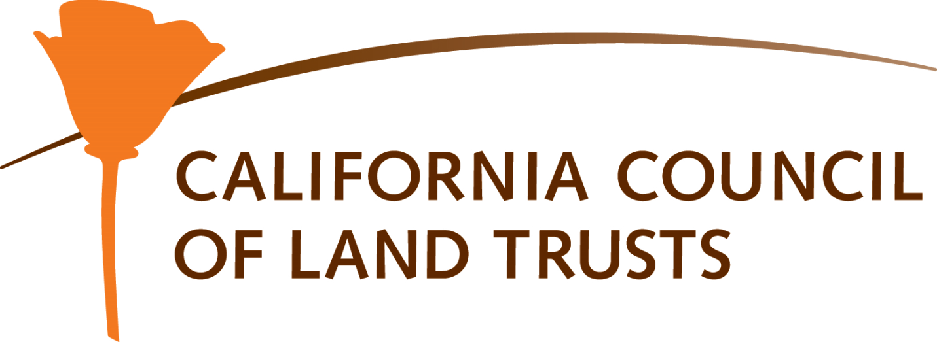
MITIGATION
The California Environmental Quality Act (CEQA) and the National Environmental Policy Act (NEPA) both require that the potential impacts on species, habitat and farmland from development be considered. Measures are taken to balance those negative impacts through a process known as “mitigation.” Mitigation is frequently required when significant impacts are identified by the environmental review process. Mitigation is defined in Section 15370 of the California Code of Regulations (CEQA Guidelines) as:
(a) Avoiding the impact altogether by not taking a certain action or parts of an action.
(b) Minimizing impacts by limiting the degree or magnitude of the action and its implementation.
(c) Rectifying the impact by repairing, rehabilitating, or restoring the impacted environment.
(d) Reducing or eliminating the impact over time by preservation and maintenance operations during the life of the action.
(e) Compensating for the impact by replacing or providing substitute resources or environment.
The need to provide measures to avoid, minimize, rectify, reduce, and/or compensate for the loss of habitat and farmland resulting from development or other land use changes has fostered the exploration of a variety of mitigation approaches in California over the last 25 years. Preservation of habitat and land to offset the loss of those resources is an approach that is fundamental to the concept of mitigation. Mitigation strategies include direct protection of land by acquisition of fee title or conservation easements, participation in a mitigation bank, term protection via deed restrictions, and in lieu fees for acquisition. Of these approaches, conservation easements are one of the most common tools used to mitigate for the loss of habitat and farmlands. Recent court cases such as Masonite[1] have upheld the validity of farmland conservation easements as a means of implementing required mitigation for the loss of other farmland due to development projects.
[1] Masonite Corporation v. County of Mendocino, No. A134896 (First Dist., July 25, 2013)

MITIGATION BANKS
Land is frequently protected to provide “mitigation” to offset the adverse impacts of development. For example, the deleterious effects of constructing a new highway that would destroy wetlands could be mitigated by acquiring and protecting other wetlands. Similarly, a housing development that would pave over farmland would mitigate that impact by acquiring and protecting other farmland. Mitigation banks are simply formed through the acquisition and protection of land by purchasing land or a conservation easement in excess of what is currently required by any specific development project. The excess land or conservation easement that is available for use to mitigate for other projects is the “mitigation bank.”
There are two basic scenarios:
- A qualified land trust, joint powers authority, or governmental agency acquires land or a conservation easement. The location, size, and natural characteristics of the land make it suitable to mitigate the impact from development projects. The organization that establishes the mitigation bank finances all the costs of creating the bank and recaptures those costs when they sell mitigation “credits” for the acres of land needed by project proponents to meet the mitigation requirements for the development of their projects. The actual land or conservation easement remains in the ownership and management of the organization that established the mitigation bank. The credits sold are deducted from the credits available at the bank until all credits have been “sold” and the bank has been fully utilized.
- A project proponent acquires land or a conservation easement on acreage that exceeds their mitigation needs. The project proponent transfers the land and/or the conservation easement to a qualified conservation holder such as a land trust, joint powers authority, or governmental agency to be held and managed for the conservation purposes. The excess acres are then available for the project proponent to use to mitigate their future projects or to make available to other project proponents for their mitigation needs. The project proponent who establishes the mitigation bank pays all the costs of establishing the bank. If other project proponents utilize the bank to meet their mitigation needs they typically compensate the project proponent who established the bank. The credits used or “sold” are deducted from the credits available at the bank until all credits at the bank has been fully utilized.
IN LIEU FEES
In lieu fees are another approach to fulfilling mitigation requirements and can be a source of funding to purchase conservation land or conservation easements. “In lieu” of the project proponent acquiring mitigation land or conservation easements, in lieu fees allow the project proponent to pay a specified fee to the lead agency or other designated agency. The in lieu fee is then intended to be used to acquire the required mitigation land or conservation easement. The acquisition is undertaken by a third party such as a land trust or government agency.
A nexus study should be prepared to defensibly establish the amount of an in lieu fee; provisions must be made so that the fee is regularly updated to ensure it is responsive to changes in real estate values. The in lieu fee should include all costs associated with providing the required mitigation including:
- Cost of the land or conservation easement
- All transaction costs including
  - Identifying and negotiating for the mitigation land or easement
  - Surveys, appraisals, title research
  - Legal review
  - Preparation of transaction documents
  - Other due diligence including environmental site assessment and mineral remoteness evaluation
- Preparation of baseline condition reports for the mitigation site
- Escrow costs and title insurance
- Staff time
- Funding for long term stewardship and monitoring of the mitigation site.
The use of in lieu fees shifts the mitigation responsibility from the project proponent to a third party such as a land trust or governmental agency. Because of this transfer of responsibility, it is essential to correctly calculate the entire cost of fulfilling the mitigation requirement to ensure that the actual number of acres is protected for mitigation purposes and the mitigation project is sufficiently funded for the long term. Any in lieu program should have a mechanism for assessing costs and adjusting the fee as needed on an annual basis. In lieu fee programs must not exceed the reasonable costs of providing the required mitigation and must meet the requirements of the 1987 Mitigation Fee Act (CA Gov. Code 66000 et seq).
CALIFORNIA COUNCIL OF LAND TRUSTS
1017 L ST. #664, SACRAMENTO, CA 95814-3805
(916) 497-0272 | MAIL@CALANDTRUSTS.ORG
COPYRIGHT © 2024 CALIFORNIA COUNCIL OF LAND TRUSTS

