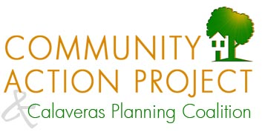
P.O. Box 935, San Andreas, CA 95249 ● (209) 772-1463 ● www.calaverascap.com
May 11, 2021
Checklist available to navigate the 2019 General Plan
Dear Editor,
The Calaveras Planning Coalition would like prospective development project applicants to know that a checklist is now available to help applicants fulfill the goals and satisfy the policies in the County’s 2019 General Plan. The checklist is available on the CAP/CPC website at www.calaverascap.com. We hope that project proponents will use this checklist and join us all in building better communities for life in the 21st century.
As the state’s General Plan Guidelines tell us, “The general plan is more than the legal underpinning for land use decisions; it is a vision about how a community will grow, reflecting community priorities and values while shaping the future.” Our County general plan expresses a desire to create a better future with a diverse economy, workforce housing, improved roads, conserved agricultural land, efficient water use, fire safety, and peace and quiet. While that may sound simple, the County’s general plan is far from simple.
The County general plan is a lengthy document divided into multiple elements. Some provisions are mandatory, while others are optional. To complicate matters further, the County has yet to draft and approve dozens of standards and practices needed to implement the general plan. This creates opportunities/burdens for project applicants to propose their own methods to fund and staff emergency services, improve infrastructure financing, reduce noise, prevent light pollution, conserve water, recharge groundwater, manage storm water runoff, control erosion, and protect streamside wildlife habitat. The County undermines the goals of the general plan by putting off implementation measures like these indefinitely, leaving project applicants and the rest of us to work extra hard to achieve those goals.
Ultimately, development project applicants are challenged to ferret out of each general plan element any requirements and any opportunities/burdens that may apply to their projects. The CPC is pleased to provide applicants with that information in one place for easy reference as they create their project proposals.
Sincerely,
Megan Fiske
CAP/CPC Outreach Coordinator

