SOUTH LAKE TAHOE TOWNHOUSE
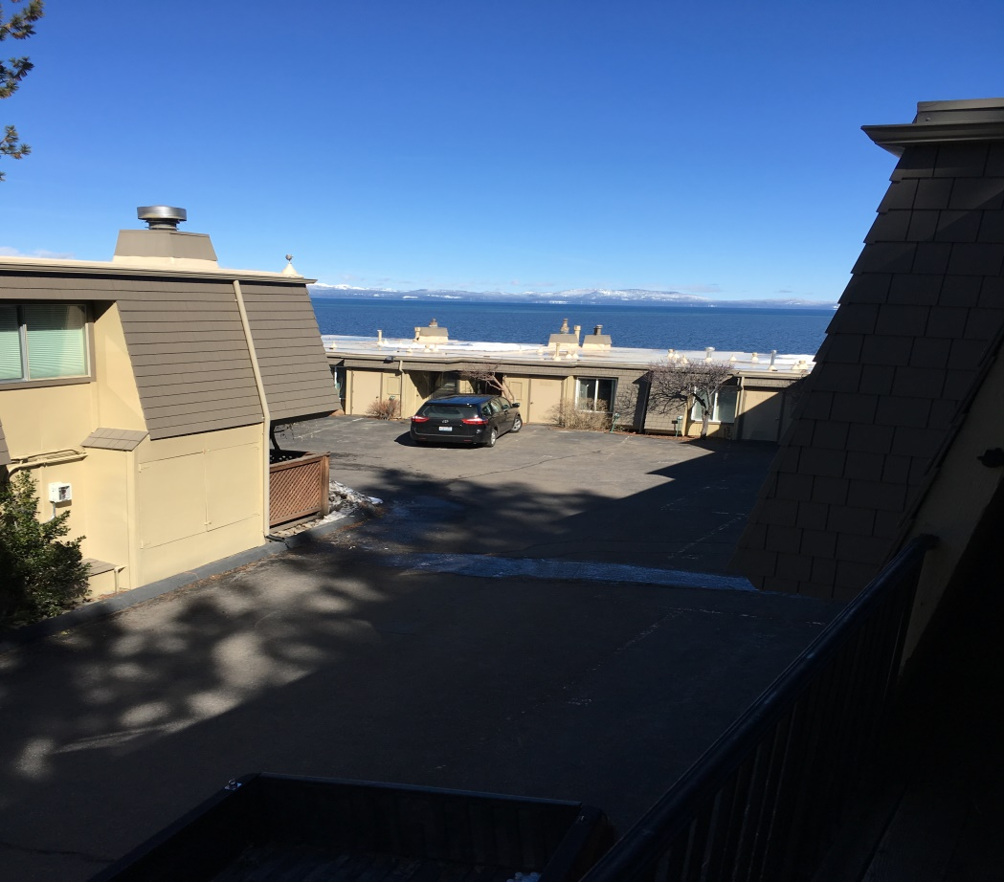
LAKE VIEW
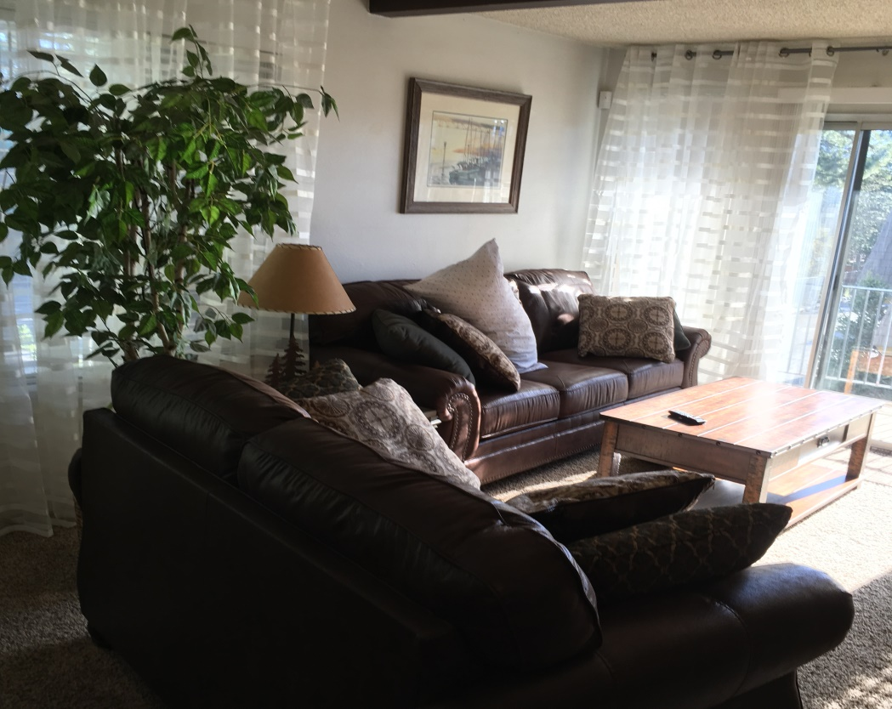

South Lake Tahoe
4 Nights
Value: $1340
Minimum Bid: $350
Required Bid Increment: $25

Small complex on the lake, balcony view. 3 bedrooms, 2.5 baths, garage. Minute walk to pool & pier. Private beach access. 2 miles from Stateline, 1 mile from Heavenly Valley. Cable TV, Wi-Fi, full kitchen, washer, dryer, fireplace. Available on mutually agreeable dates excluding major holidays. Contact: Zerrall McDaniel
209-736-9663
209-304-6837

TOWNHOUSE LIVING AREA

