How Will the Medical Cannabis Cultivation and Commerce Ordinance Affect the Quality of Life for Calaveras County Residents?
When the County is looking at the Who, What, Where, When, and How of the proposed ordinance, it is important to consider exactly how it all will impact the lives of those living in Calaveras County. The CPC has also voiced concerns regarding impacts in comments on the DEIR. These impacts include:
Residential – There are currently no minimum parcel sizes in the EIR of this ordinance. The issue of having cannabis grows in residential areas has yet to be acknowledged by the Board. Allowing cannabis grows in certain areas would negatively affect the home life of neighboring residents.
Safety – Poorly regulated commercial cannabis operations will make the illegal grows more attractive. As we have seen in various communities already, the criminal element that illegal or loosely regulated grows bring to the area not only compromises the safety of the general public, but also the safety of those growers who are involved in the community and operating legally.
Economic – Much of the County’s industry is tourism. If the above listed environmental impacts do become an issue, this will undoubtedly negatively affect the prosperity of local businesses who rely on the County’s resources for their business’ ability to cater to tourism, further limiting local businesses as well as employment. Then there is the issue of how much this ordinance will cost the taxpayers. The funding for this remains unclear.
Resource – Cannabis grows have an effect on the natural beauty and resources of the area that residents love so much. Depending on whether the grows are legal or illegal, there can be a variety of negative impacts on the water, wildlife, and visual character of the County.

The Board of Supervisors will make its final decision soon.
If you care about this issue, send your input to the Board of Supervisors: Clerk of the Board of Supervisors, 891 Mountain Ranch Road, San Andreas, CA 95249 or ‘DSeverud@co.calaveras.ca.us. The Community Action Project encourages all people affected by this decision to work with the County to draft a clear, effective, and legally sufficient ordinance that will meet the needs of each community. To receive regular action alerts on this topic, add yourself to our email list at www.calaverascap.com.

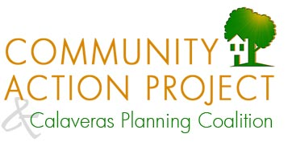
P.O. Box 935, San Andreas, CA 95249 ● (209) 772-1463 ● www.calaverascap.com

