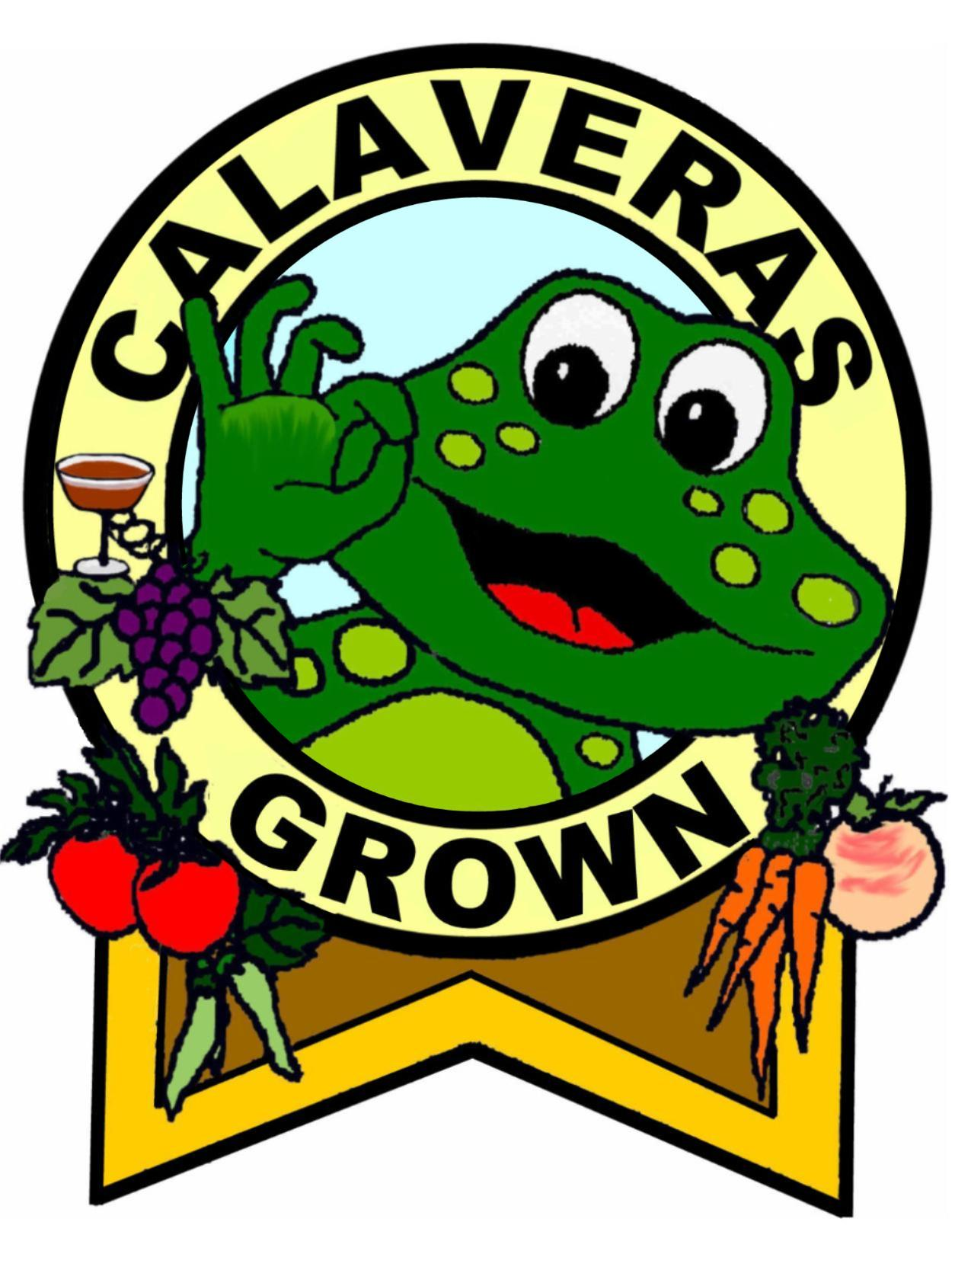
Hello Caring Community Members,

The Butte Fire has laid the soil of central Calaveras County bare to the eroding effects of the upcoming rains. This is the soil which sustains and supports the forest and without which the forest cannot grow back. In addition, this soil and the ash currently sitting on top of it are primed to pollute our waterways and the reservoirs that millions of downstream users and agriculturalists rely on. It is of the utmost importance to keep this soil where it is so that our forest can grow back and we can enjoy clean water, healthy soil and clean air. Soil, water and air are the foundations of our agriculture and tourism based economy and the mental and physical healthy of our community members.
In order to protect our soil, water, future air quality and well being CalaverasGROWN is organizing volunteer erosion control work parties. Sean Kriletich, the owner operator of Paloma Pollinators, is a geologist and a farm design consultant who can teach you how to control erosion on your land and in our community. Now that this massive fire has happened, all teaching and learning will be hands on. If you are interested in helping, or even forming work parties of your own, please come out and learn with us for a workday or two. After that you can either keep working with us or form your own work parties to help other community members and sections of forest in need.

Things to know:
-Most of the work happens on steep, slippery slopes and involves cutting trees, placing logs, moving straw bales, spreading straw or other forms of mulch. All helpers are welcome, but please know your own limitations.
-Basic direction will be provided at the beginning of the day and you can learn from others throughout the day. However, you must be a self motivated, self starter with some level of basic problem solving skills for you to be helpful.
-Work can be demanding, difficult and dangerous
-There is no insurance or workman's compensation and we are NOT responsible for your safety. You are the only one responsible for your safety.

So if you still want to help and we sure hope you do and NEED EVERYONE's HELP, read on:

-Work parties happen on Mondays and Thursdays from 10 am to 5 pm
-Meet on the work site at 10 a.m. or make arrangements to meet us in San Andreas or Mokelumne Hill
-Bring your own gloves, mask, ear protection, goggles and hard-hat
-Bring your own lunch and water, be prepared to be 100% self-sufficient
-If you are comfortable operating a chainsaw, bring yours as well as extra chains, oil and fuel
-Bring your own pocketknife for opening straw bales
-Bring your own pitchfork, pick-mattock and shovel if you have them
-Bring only positive energy and hope

Contact us for the location of the next Erosion Control Party,
The CalaverasGROWN Community and Forest Recovery Team
info@calaverasgrown.org or (209)498-8081

