December 3rd, 2013
PRESS RELEASE
Sonora, CA – The University of California Cooperative Extension is hosting a workshop on Designing, Improving & Maintaining Rural Roads from 8:00 to 4:30 pm December 13th at the Jamestown Community Hall, 18250 Main Street Jamestown, CA.
The goal of workshop is to provide landowners and land/road managers with an overview of the design and functions of low standard roads used for agriculture, resource management, residential access and recreation. The workshop will provide tools for evaluating the conditions and environmental impacts of existing roads, introduce practices that may be used to improve existing roads and eliminate problems, and outline procedures for maintaining roads to reduce potential for failure or impaired functioning especially in the aftermath of the Rim Fire.
All interested land and or/ road managers are encouraged to attend. It will also be of interest to those working for agencies that carry out, regulate and/or fund road projects. It is co-sponsored and organized by the Northern California Society of American Foresters, University of California Cooperative Extension, California Geological Survey, California Department of Forestry and Fire Protection, and the Natural Resources Conservation Service.
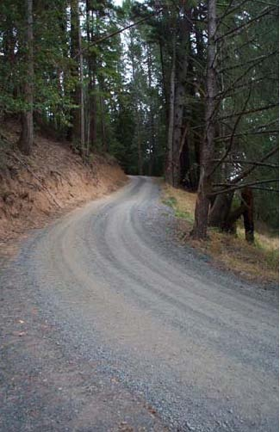
Registration is required though there is no fee to participate. Register at the webinar home page at http://ucanr.edu/2013roadworkshop/. The first half of the day will be spent inside. The second half will be an outdoor field trip, weather permitting. For more information contact Susie Kocher, University of California Cooperative Extension, sdkocher@ucanr.edu, 530-542-2571.
Figure 1. Well maintained low volume road

