Comments on DWR’s Draft Review of the
MAC IRWMP Update
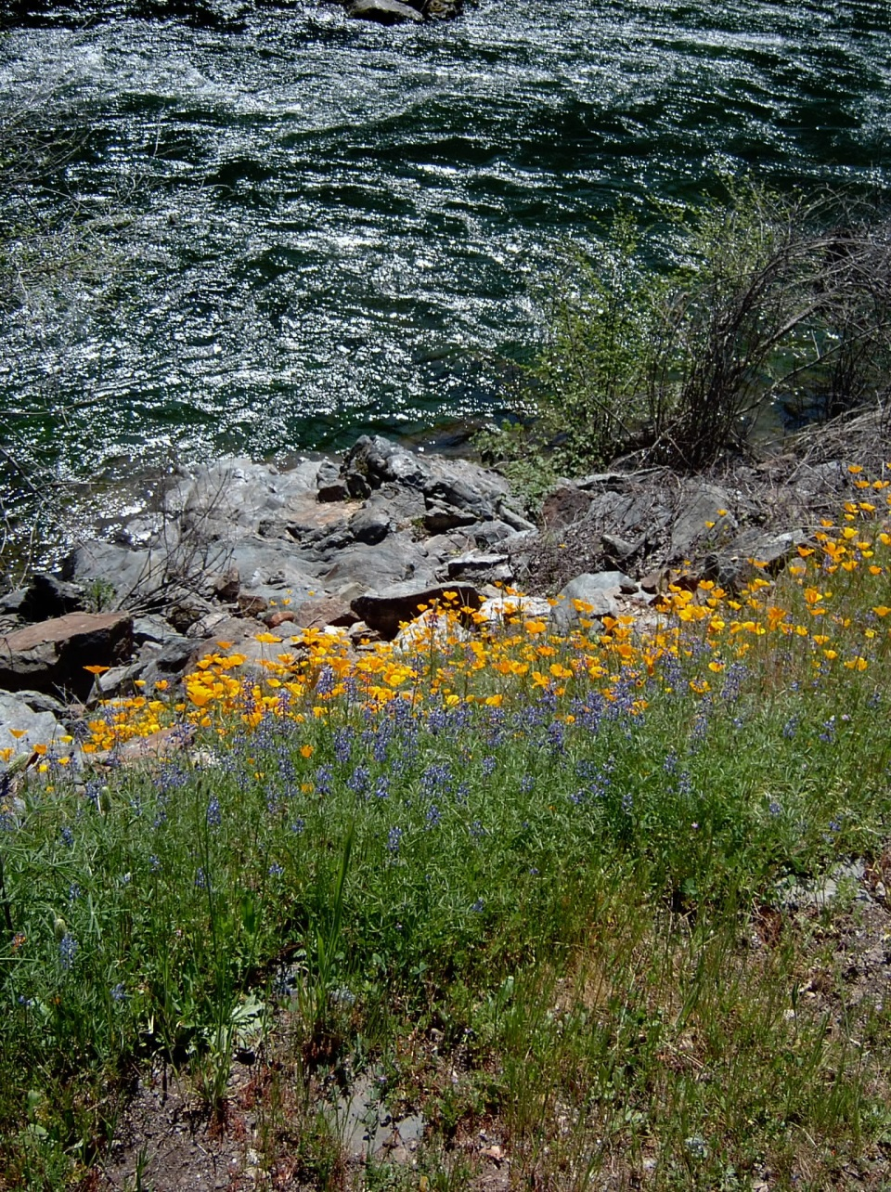
Prepared by Thomas P. Infusino
For
The Calaveras Planning Coalition
April 17, 2014
Thomas P. Infusino
P.O. Box 792
Pine Grove, CA 95665
(209) 295-8866
tomi@volcano.net

April 17, 2014

California Department of Water Resources (submitted by email & USPS)
Division of Integrated Regional Water Management
Financial Assistance Branch
Post Office Box 942836
Sacramento, CA 94236
Attention: Ted Daum
Theodore.Daum@water.ca.gov
DWR_IRWM@water.ca.gov

RE: Comments on DWR’s Draft Review of the MAC IRWMP.

Dear Mr. Daum:

My name is Tom Infusino, and I am submitting these comments on behalf of the Calaveras Planning Coalition (CPC). I have been an active member of the MAC IRWMP Regional Participants Committee (RPC) since October of 2011. I have a degree in planning from UC Davis, and a law degree from University of the Pacific. I have been involved in resource planning efforts and collaborative processes in the Sierra for over 20 years.
The CPC is a group of community organizations and individuals who want a healthy and sustainable future for Calaveras County. We believe that public participation is critical to a successful planning process. United behind eleven land use and development principles, we seek to balance the conservation of local agricultural, natural and historic resources, with the need to provide jobs, housing, safety, and services.
Thank you for the opportunity to comment on DWR’s draft review of the Final MAC IRWMP Update submitted by UMRWA. In addition to these comments, we are providing a disk of support materials for the record. Most of these documents accompanied our October 17, 2012 comments on the Draft MAC IRWMP, but were excluded from the plan’s background materials provided to DWR.
We at the CPC respectfully disagree with your draft assessment of the adequacy of the MAC IRWMP. In summary, the MAC IRWMP is substandard in the following ways.
1) The Governance Section of the plan fails to disclose the imbalance of power and lack of collaboration among stakeholders.

2) The Regional Description in the plan provides inaccurate water demand information, and misrepresents regional conflicts.

3) The Goals, Objectives, and Performance Measures Section of the plan misrepresents MAC IRWMP process as a collaborative one.

4) The Project Review Section of the plan provides an inaccurate description of the project review process, presents a project-proponent-biased evaluation of the projects, and submits a list of projects that fails to implement many provisions of the plan.

5) The Data Management Section of the plan does not identify obvious data gaps, and does not recommend ways to fill those gaps; and thus state and local decision-makers will remain without the critical information they need for rational water planning and infrastructure finance.

6) The Financing section discloses neither O&M costs, nor the percentage of funding from local sources, thereby depriving both state decision- makers and local ratepayers of the critical information they need to assess the desirability and financial feasibility of the proposed projects.

7) The Technical Analysis Section fails to disclose uncertainty regarding data used in the plan, and does not bridge data gaps as part of project or plan implementation.

8) The Water and Land Use coordination sections are tainted by the failure to disclose the unresolved controversy regarding the poor quality of land use and water demand data, and by the erosion of mechanisms to coordinate land use and water planning.

9) The Stakeholder Section does not admit that many important stakeholders did not participate in the process, as there were only two inconvenient methods of participation.

We at the CPC identified these flaws during the MAC IRWMP process, and have repeatedly presented options to improve the plan to the RPC. However, the agency-dominated RPC has indicated that it will not make any adjustments to correct alleged flaws in the plan, unless DWR directs them to do so. Thus, your accurate review of the MAC IRWMP is our last administrative hope of correcting the serious flaws in this plan.

I am sure that you are aware that DWR faces at least three risks when it improperly approves a substandard IRWMP. First, you risk the misallocation of precious public funds to undeserving regions, for unqualified projects, that stir local controversy and resentment. Second, you invite successful court challenges when you award grants to controversial projects based upon a substandard IRWMP. Third, you untimely erode the public confidence in DWR’s ability to effectively steward bond proceeds, at a time when the Brown Administration is trying to get public approval for additional water project bonds. The California Legislature, and the good people of California, depend upon DWR to faithfully implement the water code requirements for IRWMPs, so that bond proceeds are not squandered. Please do not let us down.

As one of the diligent RPC participants, we do not wish to paint all the RPC members with one broad brush. For example, to be fair to East Bay MUD, they only had one project in the MAC IRWMP, and their representative did attempt to reconcile other competing interests at the table. Also, CCWD management has changed since the days of the RPC. To be fair to the consultants, RMC Water and Environment, they were hired to write a document that would secure DWR approval. Based upon DWR’s draft review, RMC was successful in that endeavor. Regrettably, the description of the MAC IRWMP Update process that RMC wrote bears little resemblance to what actually happened, and the plan text that RMC wrote withholds critical information from decision-makers. Even more regrettably, these facts do not seem to trouble the consciences of the so called “professionals” at RMC or the water agencies. We at the CPC are submitting these comments because we are troubled that both the fictional portions and factual omission of the MAC IRWMP Update may result in the errant allocation of tens of millions of dollars of State funds.

We do not fault DWR staff for its draft review of the MAC IRWMP. Only some of our previous comments were included in the plan sent to DWR for review, and even those are well buried in Volume 3 of the MAC IRMWP. Those comments could easily have been overlooked during your review. However, now that DWR staff is aware of the problems with the MAC IRWMP, we do expect you to provide appropriate direction to UMRWA to fix the plan. (UMRWA has ample time to make MAC IRMWP improvements prior to submitting a Round 3 grant application.)

It is no longer acceptable to do “plan completeness” reviews. You can’t just look at the plan, see if it includes the information you want to find, and then put a “yes” in the plan review box. You must do compliance review. If the IRWMP process or plan did not comply with the statutes or guidelines, you cannot validate that plan.

Please take a second look at the MAC IRWMP Update.

Sincerely,

Thomas P. Infusino, Facilitator
Calaveras Planning Coalition
Member, MAC IRWMP Regional Participants Committee

Attach. Disk of Support Materials

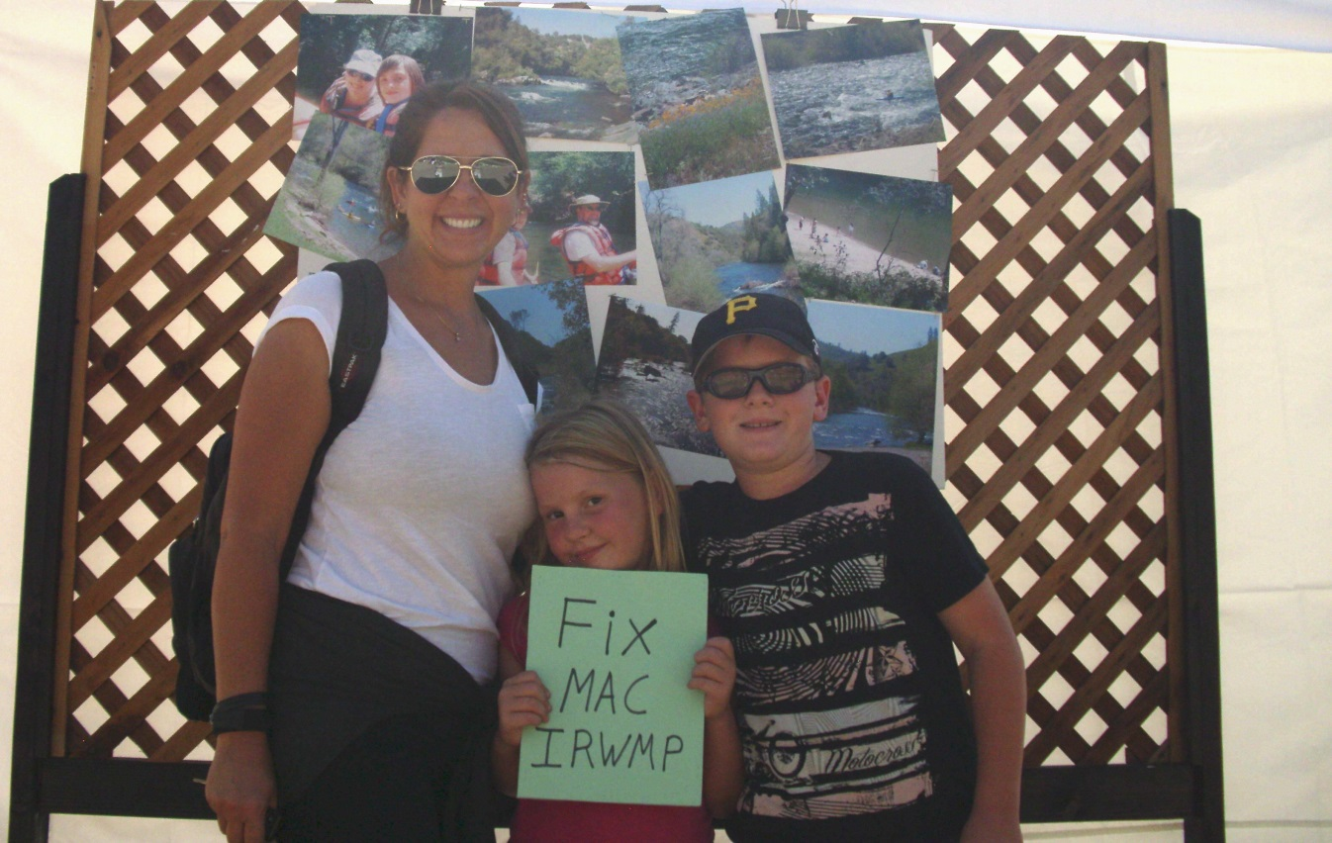

I. Governance

A) The public outreach process was unsuccessful at promoting stakeholder participation.
1) Statutory Provisions and Guideline Standards.
Water Code, Section 10540 describes the public process that DWR’s IRMW Guidelines shall require.

“(g) The guidelines shall require that the development and
implementation of an integrated regional water management plan
include a public process that provides outreach and an opportunity to
participate in plan development and implementation to appropriate
local agencies and stakeholders, as applicable to the region,
including all of the following:
(1) Wholesale and retail water purveyors, including a local
agency, mutual water company, or a water corporation as defined in
Section 241 of the Public Utilities Code.
(2) Wastewater agencies.
(3) Flood control agencies.
(4) Municipal and county governments and special districts.
(5) Electrical corporations, as defined in Section 218 of the
Public Utilities Code.
(6) Native American tribes that have lands within the region.
(7) Self-supplied water users, including agricultural, industrial,
residential, park districts, school districts, colleges and
universities, and others.
(8) Environmental stewardship organizations, including watershed
groups, fishing groups, land conservancies, and environmental groups.
(9) Community organizations, including landowner organizations,
taxpayer groups, and recreational interests.
(10) Industry organizations representing agriculture, developers,
and other industries appropriate to the region.
(11) State, federal, and regional agencies or universities, with
specific responsibilities or knowledge within the region.
(12) Disadvantaged community members and representatives,
including environmental justice organizations, neighborhood councils,
and social justice organizations.
(13) Any other interested groups appropriate to the region.”

The IRWM Guidelines properly indicate that the governance section of an IRWMP identifies which local, state, and federal officials; and which other people, participated in preparing the plan.
An IRWMP explains the structure of the committees and decision-making bodies that prepared the plan. It explains how the form of governance ensured public outreach, effective decision-making, a balanced opportunity to participate, effective communication, long-term implementation of the plan, good coordination with neighboring IRWM planning efforts, a collaborative process to establish objectives, a procedure for making interim changes, and a means for updating the plan. (2010 IRWM Guidelines, pp. 19-20, 36-39.)
A key component of the governance section provides the explanation of the public involvement process. The process should seek to include all interested parties in plan development including: water purveyors, wastewater agencies, flood control agencies, city and county governments, special district, electrical utilities, Native American tribes, self-supplied water users, environmental stewardship organizations, community organizations, tax-payer groups, recreational interests, industry organizations, state and federal agencies, and disadvantaged communities.
The Draft DWR review indicates that the Final MAC IRWMP Update achieved the governance standards for public outreach. We disagree.

2) Failures in outreach and involvement.

Governance was one of the topics for which the 2006 MAC IRWMP did not meet current IRWM Guidelines. A key reason for conducting the MA IRWMP Update was to fix the governance section of the plan.

While the language in the Governance Section of the MAC IRWMP describes a process that would comply with the IRWM Guidelines, the actual MAC IRWMP Update process did not comply. The Governance section, describes the intended purpose of the governance structure and what it was “expected” to achieve. (Final MAC IRWMP, Chapter 2, p. 2-3.) It does not describe what actually happened.

The Governance section describes “anticipated participants”, not who actually showed up and participated on the RPC or who submitted written comments on the draft plan. (Final MAC IRWMP Update, Chapter 2, p.2-4.) The Governance section generally describes the public participation for which the MAC IRWMP strives, but it does not give the details of how short the public review on the draft plan was (September 14 – October 3), and that only 4 or 5 members of the public attended the September 24 public workshop. (Final MAC IRWMP Update, Chapter 2, p. 2-7 to 2-8.) By way of contrast, when EBMUD proposed to raise the dam on Pardee Reservoir in its 2040 WSMP, they had no problem getting over 100 people to attend their public comment meetings in Amador and Calaveras counties. (Exhibit 1, Articles on EBMUD Hearings.) The discussion of integration claims that the governance structure “fosters integration,” but it does not report that the “diverse group of participants” did not arrive. (Final MAC IRWMP Update, Chapter 2, p. 2-l0.) The final plan must do that.

Instead, Section 2.2.5, Benefits of Governance, lists benefits that did not actually materialize. The “three-tiered structure” did not provide balance among stakeholders or result in a decision-making process that was “fair.” The water agencies had complete control, and everybody in the room knew it. The public outreach program did not result in “the wide participation by stakeholders and RPC members from all relevant areas of water resources management in the region.” (Final MAC IRWMP Update, Chapter 2, pp. 2-6 to 2-7.) This is an example of a systematic problem with the Final MAC IRWMP: presenting a one-sided and too rosy a picture of the actual planning process.
A major stakeholder participation problem was that the lengthy commitment to participate on the RPC (October 2011 to January 2013) during weekday working hours, drove stakeholders away from the planning process. The only other opportunity to participate was through the very limited public comment process. There needed to be more opportunities to participate and to provide input into the planning process between the two poles of full on RPC membership and mere public commenter status.
By the time I joined the RPC in October 2011, the RPC had limited regular participation and limited intermittent participation. (Though I am not listed as an RPC member on Table 2-3, you can verify my membership at Final MAC IRWMP Update, Volume 1, Appendix B, RPC Meeting Notes, Minutes for October 12, 2011, p. 3.) The water agencies (AWA, CCWD, EBMUD, and JVID), the Foothill Conservancy, the CPC, and the City of Plymouth attend regularly. We have had occasional visits from the City of Jackson, and the Forest Service. Trout Unlimited came initially and withdrew. The City of Ione attended one meeting. (See Final MAC IRWMP Update, Volume 1, Appendix B, RPC Meeting Notes.)
Unfortunately, a lot of important parties did not attend the RPC meetings, or dropped out along the way. Wastewater Agency ARSA did not attend, nor did the City of Sutter Creek that depends on ARSA for wastewater treatment. Both these entities have proposed wastewater treatment solutions that are not necessarily consistent with the regional plant proposed by AWA as one of the MAC IRWMP projects. The County Health Departments, responsible for regulating septic systems and small potable water systems, did not attend. The electrical utility, PG&E did not participate, even though expansion of one of its facilities (Lower Bear River Reservoir) is a project in the plan. Special Districts, like the Fire Districts who allegedly depend on the upgraded pressurized water systems under consideration for funding, did not participate. The Sanitation Districts from Mokelumne Hill and San Andreas, potential key partners in water recycling, did not attend. BLM did not attend, though they are a major landowner with jurisdiction over abandoned mines and their drainage remediation, and are actively promoting recreation on the Mokelumne River. Native American Tribes, a key constituent that the IRWMP is supposed to consult and serve, did not participate. Taxpayer and ratepayer groups did not participate in the RPC, but one did provide public comments on the projects. Though one realtor did sign up to participate, she did not subsequently attend, even though she was the only representative from the business and industrial sector.
Because the RPC did not create more opportunities to get input from these very important parties, the MAC IRWMP list of participants is far too narrow.
3) Our recommendations were not accepted.
The decision process for RPC participation indicated that members raising concerns must also recommend solutions to address those concerns. (RPC Governing Procedures Guidebook, p. 4.)
We recommended that, over the course of a year, the RPC hold a series of individual meetings to invite key missing stakeholder groups to put their two cents worth in on the plan (i.e. city and county governments planning and health department staff, school districts, Calaveras COG & ACTC, electrical utilities, Native American tribes, self-supplied water users, community organizations, tax-payer and ratepayer groups, recreational interests, industry organizations, state and federal agencies, and disadvantaged communities.). For example, on one day you could have a meeting with City and County planning staff, COG staff, ACTC staff, School Districts. If this did not work, delegate to RPC volunteers the responsibility of meetings one-on-one with additional stakeholder groups or their representatives to brief them on the plan and get their input. If UMRWA or the RPC had accepted that recommendation as late as January of 2013, we would be done with that effort already. However, rather than implementing this recommendation, the RPC accepted consultant RMC’s recommendation to defer this effort and add the suggestion to the Final MAC IRWMP Update section entitled “Considerations for Future Updates”. (Final MAC IRWMP, Volume 3, Appendix G, Response to Comment, Number 17; See also Volume 1, p. 4-15.)
We encourage DWR to direct UMRWA to complete a better public outreach effort.

B) Failure to provide a balanced opportunity for collaborative participation in the IRWM process.
1) Statutory Provisions and Guideline Standard.
Water Code Water Code Section 10541 indicates the IRWMP must describe the collaborative decision making process used to engage a balance of interested persons in the process, regardless of their financial contribution.

“(h) The guidelines shall require integrated regional water
management plans to be developed through a collaborative process that
makes public both of the following:
(1) The process by which decisions are made in consultation with
the persons or entities identified in subdivision (g).
(2) The manner in which a balance of interested persons or
entities representing different sectors and interests listed in
subdivision (g) have been or will be engaged in the process described
in this subdivision, regardless of their ability to contribute
financially to the plan.”

The IRWM Guidelines properly indicate that the governance section of an IRWMP explains how the form of governance ensured effective decision-making and a balanced opportunity to participate in a collaborative process. (2010 IRWM Guidelines, pp. 19-20, 36-39.)
The Draft DWR review of the Final MAC IRWMP indicates that the plan meets the standards for effective decision making, and for the balanced access and opportunity to participate in the IRWMP process. We disagree.

2) Failures to provide an opportunity for balanced participation in a collaborative process.

The fact that anything not resolved by the RPC would go to agency-only groups for review and recommendation to UMRWA removed any need or effort by the agencies to discuss or negotiate the controversial issues, and provided a strong disincentive for NGO’s to participate. (Final MAC IRWMP, Volume 1, pp. 2-3 & 2-6.) This disincentive was only reinforced by the fact that non-applicant information was neither considered in project review, nor disclosed in the IRWMP, without the consent of the applicants. (Final MAC IRWMP, Volume 1, Meeting Notes of May 22, 2012, p. 4; Meeting Notes of August 29, 2012, p. 6; Meeting Notes of September 24, 2012, p. 3.)
The agencies dominated the RPC, the Review Committee, and UMRWA. There was no standard of review by those bodies, no procedures for appeals to those bodies, and no mechanism for accountability if they abuse their discretion. This did not provide RPC participants with and equal voice or power. It did not promote public participation in the process. It did not result in working out issues of concern in a collaborative way.
When I raised this issue at the RPC meeting on September 24, 2012, the facilitator from UMRWA quipped that he was O.K. if I wanted to give up some of my power. Another RPC member questioned that the guidelines called for equal power and equal voice for all members. So I read from the guidelines, “Equal distribution of power and voice among stakeholders.” (2010 IRWM Guidelines, p. 38.) Then he asked if I was also willing to share equally in financial responsibility with the other RPC stakeholders. So I again read from the guidelines, “[T]he opportunity to participate, regardless of their ability to contribute financially to the IRWM Plan.” (Ibid.) His response was that the Guidelines are not etched in stone, and the troublesome ones can be changed. Clearly we have a long way to go on the road toward collaboration.
Nowhere was this imbalance of participation more evident than in the ability of an RPC participant to contribute information to the plan. When it came to evaluating project, it was the project applicant’s information or the highway. Unless the NGOs and the public could convince the agency to voluntarily change the description of their project, or their self-reported ranking on their project, the MAC IRWMP accepted the agency’s version of the facts without question, even when there was ample evidence to the contrary in public comments. (Final MAC IRWMP, Volume 1, Meeting Notes of May 22, 2012, p. 4; Meeting Notes of August 29, 2012, p. 6; Meeting Notes of September 24, 2012, p. 3.) Telling the NGOs that all they had to do is convince the water agencies to downgrade its self-assessment of its proposed project, was like telling a slave that all he had to do to be free was convince his master to set him free.
For example, comments by the Ratepayer Protection Alliance (RPA), and adopted by one RPC member as his own, indicate that 18 of the Amador Water Agency’s (AWA) first 20 project have a high risk of not being implemented (i.e. rated 7 or greater on a scale of 1 to 10). (Exhibit 2: RPA Comments May 2012.) One of the RPA’s key concerns is the equitable distribution of project costs and benefits among existing ratepayers and future customers. This concern is verified by AWA failure to demonstrate an equitable distribution of benefits for 17 of their first 20 projects. (Final MAC IRWMP, Volume 1, Appendix C, Table Tier 1-Screening, Step 1 - Reflect Goals and Statewide Priorities.) The RPA can make the risk assessment with credibility, because it knows its member base, and it has already participated in three successful Proposition 218 protests against AWA rate increases. (Exhibit 3: RPA 218 Protest Results.) Such protests can severely hamper AWA’s ability to implement projects.
Despite this important information submitted by an RPC member, the AWA self-assessment of the probability of implementation rates only 2 of its first 20 projects as having a high risk of not being implementation. (Final MAC IRWMP Update, Volume 1, Appendix C, Table Tier 2 - Evaluation, Step 1 –Apply Evaluation Criteria.) Furthermore, it is only that AWA assessment that is presented in the spread sheet evaluating projects in the main Volume of the Final MAC IRWMP. The RPA’s written comments, though arguably of equal or greater value, are buried in Volume 3 of plan. This does not reflect equal power or voice for RPC participants. It erodes claims of collaboration.
For another example, RPC member the Foothill Conservancy assessed the projects on the degree to which they were the best to able achieve the purpose, from an economic, environmental, and societal perspective: the so called triple bottom line. (Exhibit 4: Foothill Conservancy Comments 5/30/ 12.) The Foothill Conservancy expressed serious concerns about whether 5 of the AWA’s first 19 projects (i.e. Numbers 7, 10, 11, 12, 13) were actually the best to achieve the purpose. Nevertheless, the AWA scored all of those projects high for that criterion. (Final MAC IRWMP Update, Appendix C, Table Tier 2 – Evaluation, Step 1, Apply Evaluation Criteria.) Yet it is only the AWA assessment that appears in the main volume of the MAC IRWMP. The Foothill Conservancy Comments are buried in volume three of the plan. This does not reflect equal power or voice for RPC participants. It erodes claims of collaboration.
For another example, when it comes to supply and demand data, unless the NGO’s could convince the agencies to change their data voluntarily, the consultants said that they would accept only the agency version, regardless of ample evidence to the contrary. (See comments on Regional Description, below.) This does not reflect equal power or voice for RPC participants. It erodes claims of collaboration.
Finally, even when the public and the agencies agree that there are data gaps, the IRWMP does not specifically identify the need for additional studies as part of a project, and does not ask for funds to fill those data gaps. A major data gap is that, although the AWA has proposed over 190 million dollars in projects, AWA has no capital improvement plan that identifies, phases, prioritizes, or finances these projects, or has the approval of the AWA Board and its ratepayers. (Final MAC IRWMP Update, Volume 1, Appendix D, Project Summary Table.) Yet, no proposed AWA project includes the funding and preparation of such a strategic capital improvement plan. Also, although CCWD proposes to “restore” ephemeral streams by using them as conduits to deliver, the project does not specifically call for the study of the previous natural hydrograph to guide this restoration. (Project 23 – New Hogan Reservoir Pumping Project.) In addition, although there is an admitted need for additional studies to clarify CCWD’s future agricultural water demand, no proposed CCWD project includes the funding for these studies. (See Regional Description comments below.)
Thus, incomplete agency information may just languish as such, and remain a shaky and controversial basis for seeking funding. This does not reflect equal power or voice for RPC participants. It erodes claims of collaboration. It perpetuates weaknesses in the data that instead should better reflect the merits of the projects.
When one member or group at the table can dictate the contents of a plan, regardless of the objections of others at the table, and regardless of the facts in the record, then it ceases to be a collaborative planning process with a balanced opportunity to participate. That is exactly what happened during the MAC IRWMP Update.
Though both the Foothill Conservancy and RMC made recommendations for reforming the governance structure, that consideration was also deferred to the next Final MAC IRWMP Update. (See Final MAC IRWMP Update, Volume 3, CPC Comments on the Draft UWMP p. 1-30, p. 10; Final MAC IRWMP, Volume 3, Response to Comment, Number 17.)
We encourage DWR to direct UMRWA to restructure MAC IRWMP governance, and to reconsider the inclusion of RPC participant and public information in the text of the plan. We also encourage DWR’s grant review staff to review the public comments on the MAC IRWMP, and the attachments we have provided to validate our allegations regarding plan data quality (or lack of quality). We do not want DWR to be misled in any of its deliberations on MAC IRWMP projects.
C) Collaboration in the establishment of plan objectives.
1) Statutory Standards and Guidelines.
Water Code Water Code Section 10541 dictates the collaborative governance standards that DWR must describe in its IRWMP Guidelines.
“(e) The guidelines shall require that integrated regional water
management plans include all of the following:
(5) An integrated, collaborative, multibenefit approach to
selection and design of projects and programs.”

“(h) The guidelines shall require integrated regional water
management plans to be developed through a collaborative process that
makes public both of the following:
(1) The process by which decisions are made in consultation with
the persons or entities identified in subdivision (g).
(2) The manner in which a balance of interested persons or
entities representing different sectors and interests listed in
subdivision (g) have been or will be engaged in the process described
in this subdivision, regardless of their ability to contribute
financially to the plan.

The IRWM Guidelines properly indicate that the governance section of an IRWMP explains the collaborative process used to establish objectives. (2010 IRWM Guidelines, pp. 19-20, 36-39.)
The Draft DWR review of the Final MAC IRWMP indicates that the plan meets both the Governance and the Objectives standards for a collaborative process used for establishing plan objectives. We disagree.

2) Failure to use a collaborative process to establish plan objectives.

The discussion of plan objectives is in Section 3.1 of the Final MAC IRWMP.
I take issue with initial sentence in this section stating that the goals and objectives “were formed through a collaborative stakeholder process.” This was stakeholder negotiation, not collaboration. Each side represented its own interests, and did not try to arrive at mutual understanding. The result was consensus based upon exhaustion and pending deadlines, not upon mutual understanding.
When I raised this issue at the RPC, I was told that I was reading too much into the word “collaboration”, and that the Wikipedia definition of collaboration was the operative one for our RPC. That definition was as follows:
Collaboration is working together to achieve a goal.^{[1]} It is a recursive^{[2]} process where two or more people or organizations work together to realize shared goals, (this is more than the intersection of common goals seen in co-operative ventures, but a deep, collective, determination to reach an identical objective^{[by whom?][original research?]}) — for example, an intriguing^{[improper synthesis?]} endeavor^{[3][4]} that is creative in nature^{[5]}—by sharing knowledge, learning and building consensus. Most collaboration requires leadership, although the form of leadership can be social within a decentralized and egalitarian group.^{[6]} In particular, teams that work collaboratively can obtain greater resources, recognition and reward when facing competition for finite resources.^{[7]} Collaboration is also present in opposing goals exhibiting the notion of adversarial collaboration, though this is not a common case for using the word.
Structured methods of collaboration encourage introspection of behavior and communication.^{[6]} These methods specifically aim to increase the success of teams as they engage in collaborative problem solving. Forms, rubrics, charts and graphs are useful in these situations to objectively document personal traits with the goal of improving performance in current and future projects.
Since the Second World War the term "Collaboration" acquired a very negative meaning as referring to persons and groups which help a foreign occupier of their country—due to actual use by people in European countries who worked with and for the Nazi German occupiers. Linguistically, "collaboration" implies more or less equal partners who work together—which is obviously not the case when one party is an army of occupation and the other are people of the occupied country living under the power of this army.
In order to make a distinction, the more specific term Collaborationism is often used for this phenomenon of collaboration with an occupying army. However, there is no water- tight distinction; "Collaboration" and "Collaborator", as well as "Collaborationism" and "Collaborationist", are often used in this pejorative sense—and even more so, the equivalent terms in French and other languages spoken in countries which experienced direct Nazi occupation.
Given that definition, it was not a collaborative effort. We did not have “shared goals” and “identical objectives.” The water agencies had their pet goals and the NGO’s had theirs. The water agencies had their pet objectives, and the NGO’s had theirs. The lack of collaboration is even more obvious when one looks at the agency-driven projects list that neglects key resource concerns like tribal waters, agricultural land stewardship, and climate change adaptation. (See comments on Project Review Process.) As noted above in the discussion of Governance, we were not “equal partners who work together.” We were negotiators on an uneven playing field. This process was not collaborative, like Rogers and Hammerstein writing a musical. It was competitive: much more like an Ali v. Frazier boxing match.
Surprisingly, it was the opinion of the DWR observer that the process was collaborative. (Final MAC IRWMP Update, Volume 3, Response to Public Comments, #42.) If this is how DWR staff collaborates, it is amazing that you get anything done! If you call what the RPC did collaboration, I would hate to see what you fellas at DWR call a fight.
The description of the objective setting process in Chapter 3 is an example of what I referred to above as “a one-sided and too rosy a picture of the actual planning process.” The actual process was characterized by behavior that was petty, opinionated, and insulting; and not the only from me. I am pretty sure that Hank Willey from Jackson Valley Irrigation District could have walked into the RPC meeting room, pulled out a gun, blown my head off, and RMC would still have mischaracterized his action as part of, “A consensus-based approach.”
Although we recommended that the information in the MAC IRWMP be rewritten to reflect the actual events associated with setting the plan objectives, the RPC refused. (Final MAC IRWMP Update, Volume 3, Response to Public Comments, #42.)
While reasonable minds may differ on this subject, we do not believe that it is appropriate for DWR to give credit to the MAC IRWMP for sponsoring a collaborative process for the selection of plan objectives, based upon the definition of collaboration noted above. If UMRWA wishes to claim that the process was collaborative, we encourage DWR to direct UMRWA to come up with a definition of collaboration, and a description of the process, that accurately reflects the events that transpired.

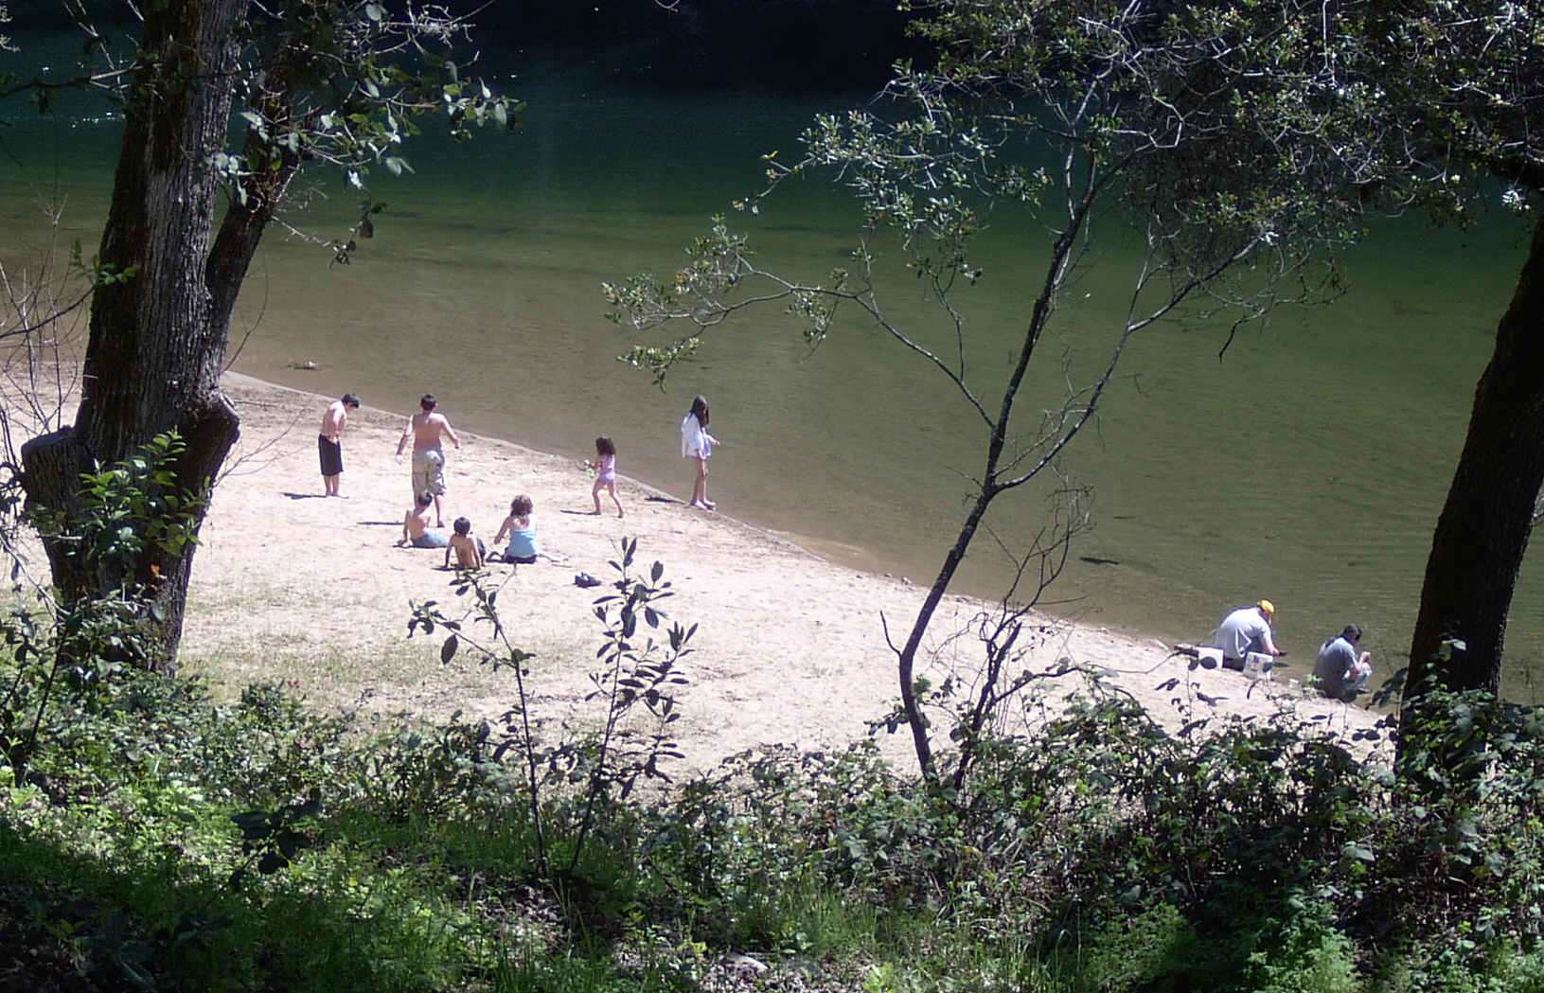

II) Region Description
A) The water demand estimates are inaccurate.
1) Guideline Standard
The IRWM Guidelines indicate that the Region Description section in a plan describes the water supply and demand for the 20-year planning horizon. (2010 IRWM Guidelines, pp. 20-21, 39-41.)
An IRWMP is supposed to use those portions of the local plans that are "current and relevant". (2010 IRWM Guidelines, p. 60.) The Guidelines do not require you to use the exact same data as the local plans. In fact, the Guidelines provide the opportunity to include different data, and to explain why. (2010 IRWMP Guidelines, pp, 40 & 41.) Also, the Guidelines require one to disclose the quality of the data, to identify data gaps, and to explain how the IRWMP will fill these gaps. (2101 IRWM Guidelines, p. 56, 59, and 60.)
The Draft DWR review of the Final MAC IRWMP indicates that the plan meets the standards for describing water demand. We disagree.

2) Failure to provide accurate demand information.
Final MAC IRWMP Update, Page 1-27 states, “The regional water supplies and demands included in this section are agency estimates based on the best available information and projections.” Again this is another example of the IRWMP’s one-sided and too rosy a picture of the actual planning process.
The AWA estimate is based upon “the projected growth described in the local general plans.” What does that mean? Some of the growth estimates in the local government general plans are not based upon current or reliable data. The Sutter Creek general plan dates from 1994. The Amador County General Plan was approved in 1974. Is that the growth data used by AWA to estimate future demand? Since then, those local governments have updated their Housing Elements with more current growth data. (See Exhibits 24 and 25 for recent growth and projected growth.) Is that the data used by AWA? Mysteriously, the AWA increased its estimate of Amador County’s average annual growth rate from less than 1% in the old UWMP to 1.8% in the new UWMP. Although the Foothill Conservancy asked for some explanation during the UWMP update in 2011, none was forthcoming. (Exhibit 12, Foothill Conservancy on AWA UWMP.) Unfortunately, there was no opportunity for the RPC to discuss those issues before accepting the demand projections from AWA.
On page 1-31, the demand figures for CCWD include a growth in raw water demand for the Valley Springs Area of nearly 16,000 acre-feet per year by 2035. This is based upon a study that identified the need for over 100,000 acre-feet of water per year to irrigate 29,000 acres of agricultural land in Calaveras County. (Exhibit 13, CCWD Irrigation Study, p. 10.)
However, that study recognizes huge deficiencies in the data, not the least of which is that parcelization and development in the rapidly growing Valley Springs area over the last 40 years has gobbled up much of the acreage previously considered suitable for irrigation. The study also generally cautions that “this analysis utilizes a data set that is 30 to 45 years old. This information needs to be verified and ‘ground truthed’ before committing to plans for agricultural development.” (Exhibit 13, CCWD Irrigation Study, pp. 10 & 12.)
The 12-page study includes more than a page-long list of 9 essential future follow-up studies:
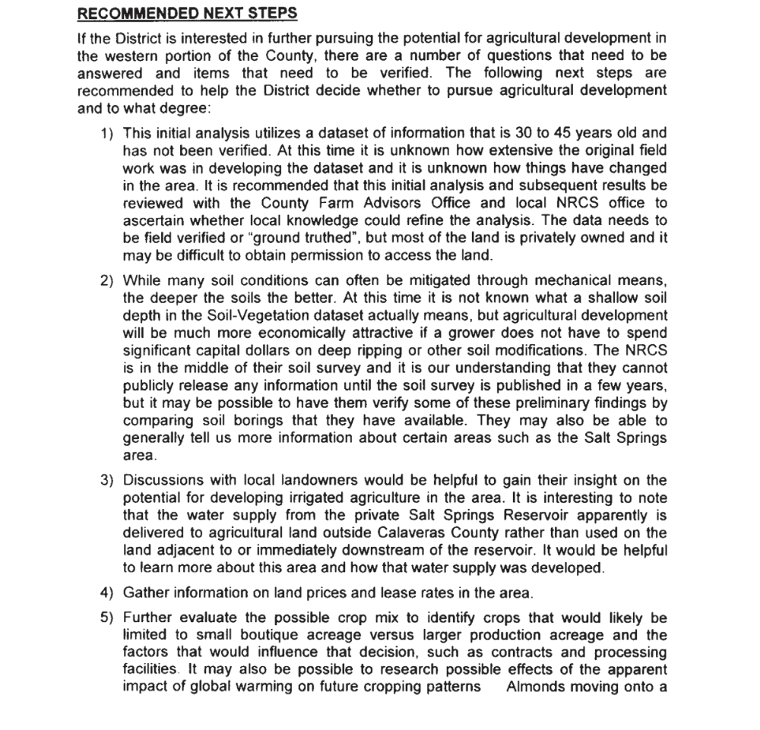
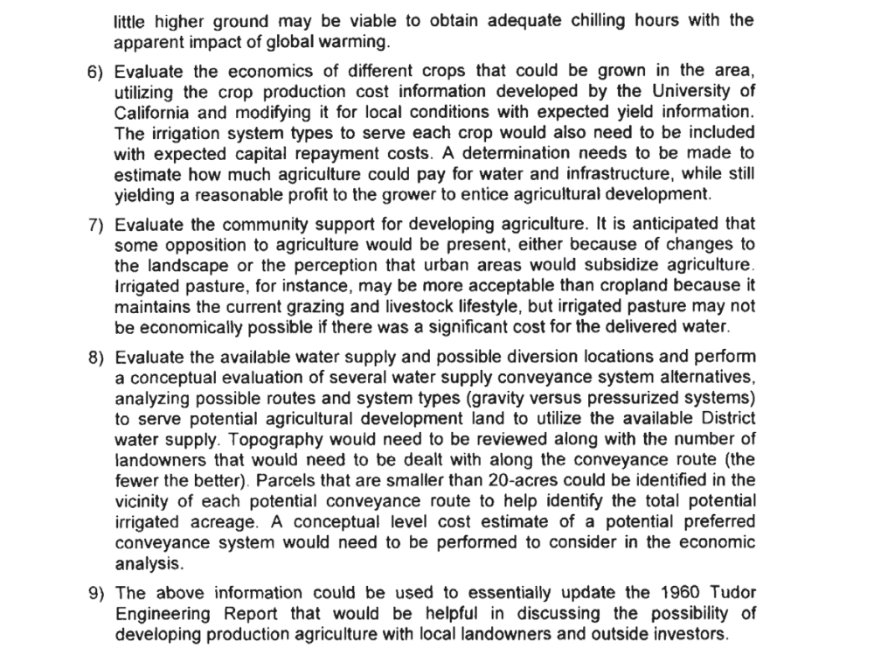 Despite this serious data gap that affects the MAC IRWMP, CCWD has not proposed a project to fill this gap.
Even though CCWD has not provided any studies that investigate these data gaps further, there is ample data available that calls into question the feasibility of developing this level of irrigated agriculture in Calaveras County.
For example, evidence of the growth or decline of irrigated agricultural lands in the Sierra Nevada Foothill counties over the last decade indicates that the greatest amount of additional irrigated agriculture in any such county is 1,638 acres. In fact, another foothill county LOST 2,158 acres of irrigated lands to conversion. (Exhibit 14 – CPC Comments on CCWD UWMP, pp. 10-12.)
Furthermore, CCWD’s study admittedly provided no consideration for the fact that the demand for irrigation water will be very sensitive to its price. However, there is data available on the estimated cost of the irrigation water and the value of agricultural crops that can shed light on the economic feasibility of irrigation. Two projects recently considered for tapping CCWD’s area of origin water reservations on Mokelumne River were Pardee Expansion and the Inter-Regional Conjunctive Use Project (IRCUP). The estimated cost of water for these for these projects was $730 per acre foot, and $670 per acre foot respectively. (Exhibit 15, EBMUD Technical Memorandum #6, Cost Estimation Evaluation, 2009, p. 10.) CCWD’s study estimates that water usage will be about 3.5 acre-feet per acre. Thus the cost of the irrigation water would be between $2345 per acre and $2555 per acre. The 2009 Annual Crop Report for Calaveras County indicated that only the 800 acres of the county planted in wine grapes yielded a crop valued at more than $2300 per acre. Furthermore, much of the land slated for irrigation is rangeland, that when irrigated produces less than $150 of crop value per acre. (Exhibit 16, Calaveras County, 2009 Report of Agriculture.) Thus, the notion in CCWD’s irrigation study that every acre of land available for irrigation will be irrigated with 3.5 acre-feet of water per acre is without basis in fact. It is simply not economical to do so.
Nevertheless, it is only CCWD’s reported demand level, based upon a seriously inadequate study using admittedly outdated data, that is reflected in the MAC IRWMP. In addition, this data is used with no reference to CCWD’s irrigation study’s disclaimers, or to the other data suggesting that the demand estimate is inflated.
We understand that CCWD seeks to inflate its future agricultural demand in an effort to protect its area of origin water reservations against outside intrusion. However, this 12-page study with its long list of caveats is far too small a fig leaf with which to clothe CCWD’s area of origin water reservations. CCWD would be much better served by actually securing those rights in the present, than by pretending to be able to secure them through a most unlikely future scenario.
What is very distressing about this situation is that this issue of irrigation demand has been raised with CCWD staff, CCWD management, and heard by the CCWD board during the UWMP process, all to no avail. (Exhibit 14 – CPC Comments on CCWD UWMP.) One would hope that the collaborative and regional IRWMP process would provide a forum for resolving these data credibility issues prior to placing unreliable data into the IRWMP. Instead, the IRWMP consultant staff, the facilitator, and the water agencies refused to address these issues.
We hope that DWR’s IRWMP plan review staff will not be as quick to ignore these data credibility issues. We encourage DWR to direct UMRWA to amend the Final MAC IRWMP Update to present more than just the agencies' chosen data on demand, to acknowledge the low quality of some of that demand data, and to identify the efforts that will be made in the future to fill those data gaps.

B) The MAC IRWMP misrepresents regional conflicts.
1) Statutory Provisions and Guideline Standards.

Water Code Section 10541, Subdivision (e)(3), indicates that the IRWM Guidelines must require that an IRWMP include a, “Description of the major water-related objectives and
conflicts within a region.” The IRWM Guidelines properly indicate that the Region Description in a plan describes the major water related conflicts. By identifying the water systems and issues of concern to people, those working on the IRWMP can try to include a sufficient variety of interested parties in the planning process. (2010 IRWM Guidelines, pp. 20-21, 39-41.)

The Draft DWR review of the Final MAC IRWMP indicates that the plan meets the standard for describing major water related conflict. We disagree.

2) Failure to accurately describe the water resource conflicts.

Final MAC IRWMP Update Section 1.4 discusses water resource issues and major conflicts. Many of these issues are covered in only a single inaccurate sentence presenting false dichotomies.
For example, “Watershed protection versus community economic needs.” There is no need for watershed protection to conflict with community economic need. This is being proven by the Amador Calaveras Consensus Project that is putting people back to work in the forest; this time on restoration and fuel reduction projects. If the phrase was “Watershed protection versus watershed damaging forestry practices” then it would reflect a true conflict and a true dichotomy.
For another example, “Insufficient groundwater quantity and quality to accommodate growth.” What does that mean? Does it mean insufficient groundwater quantity and quality to build out isolated rural parcels at their maximum allowed land use intensity under the existing General Plan and Zoning? If so, that does reflect real conflict among groundwater users.
Yet another example, “Obtaining Wild and Scenic River status versus preserving opportunity to develop additional surface water storage.” This is another false dichotomy. The only surface water storage that Wild and Scenic River Status prevents is on-stream storage. Wild and Scenic River Status will not affect existing water rights, and will not prevent the development of off-stream storage facilities. If the issue is “Obtaining Wild and Scenic River Status down to Pardee Reservoir versus preserving the opportunity to inundate more of the Mokelumne River with dams,” then that would reflect a true dichotomy and a true conflict.
Yet another example, “Protecting and improving fish passage on the lower Mokelumne and Calaveras Rivers versus river-sourced water supply development needs and opportunities.” Trap and haul operations could improve fish passage without large reductions in water supply development projects. Also, Calaveras County could perfect its area of origin water rights well before they are needed for domestic use, by storing and releasing the water to improve fishery conditions. In these ways, fishery improvements can occur without serious harm to water project operations. If the phrase is “Protecting and improving fish passage on the lower Mokelumne and Calaveras Rivers at the water diverters expense,” then you do identify a true conflict and a true dichotomy.
I have no idea what is meant by, “Wastewater treatment levels and technology versus environment and benefits.”
Our communities have been harmed enough by people promoting false dichotomies. There is no need for the MAC IRWMP to engage in that. Unfortunately, as one would expect, the failure to identify the conflicts correctly only highlights the need to include a broader scope of participants in the process. For example, it would have helped to have a County or City planner in the room to explain the true nature of the groundwater water supply and land use conflict.
Based upon the recommendation of the consultant RMC, the RPC refused to correct these inaccurate statements, and instead postponed modifying them until the next IRWMP Plan Update. (Final MAC IRWMP, Volume 3, Response to Comments, Numbers 36 through 40.)

We recommend that DWR direct UMRWA to amend the Final MAC IRWMP to rephrase the water conflicts noted above so that they accurately represent the true areas of conflict.

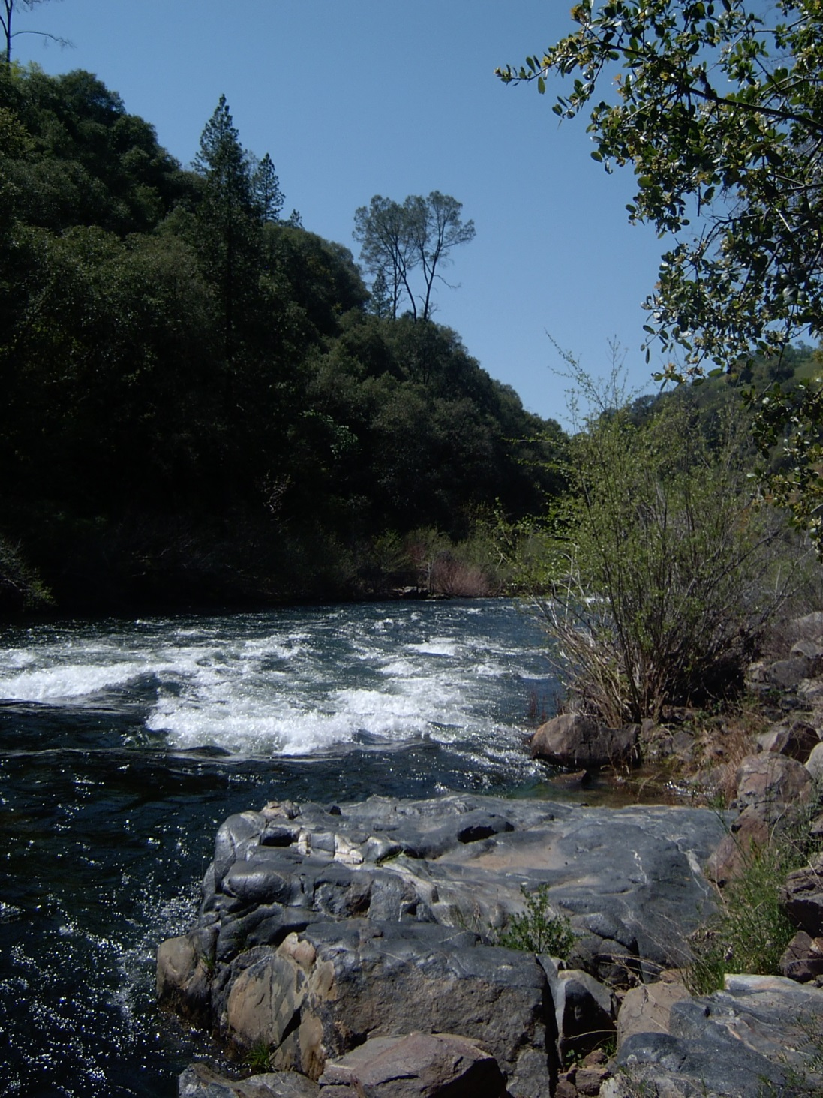

III. Project Review
A) The Final MAC IRWMP project list does not implement some aspects of the plan.
1) Guideline Standards.
An IRWMP must include the process used to submit and to select the water projects included in the IRWMP. Project review must consider how the project contributes to achieving the plan objectives, and to implementing the regional management strategies. Finally, the project review must consider a project’s strategic role in IRWMP implementation. (2010 IRWM Guidelines, p. 21-22, 47-51.)
The Draft DWR review of the Final MAC IRWMP indicates that the plan passes the standards for projects meeting plan objectives, and for project strategically implementing the plan. We disagree.

2) The projects poorly implement some statewide priorities and some resource management strategies.
Section 4.1 of the Final MAC IRWMP discusses the project review process.
A careful review of the Appendix C Tables on Tier 1 Screening reflects that some resource management strategies are seriously neglected in the project list for the MAC IRWMP Update.
Only 2 of the AWA’s 24 projects improve tribal waters, even though they have a significant Native American population in their service area. Only 5 of AWA’s 24 projects ensure equitable distribution of benefits. This confirms concerns found in comments by the Ratepayer Protection Alliance.
Although the region’s politics is dominated by anti-regulation and pro-economic incentive rhetoric, there are only 5 economic incentive projects.
Despite the historical and current prominence of the agricultural sector in our region, there are no agricultural land stewardship projects.
There was little or no effort by the local agencies to develop projects to deal with issues like equity and economic incentives, as these do challenges do not lend themselves to the engineered concrete solutions more familiar to the agencies.

We hope that DWR will direct UMRWA to develop more projects to implement the underserved statewide priorities and regional management strategies.

B) Proponent self-scoring and censorship of public concerns resulted in skewed project descriptions.
1) Guideline Standards.
An IRWMP includes a list of the selected projects that systematically compares the projects against the various plan objectives, resource management strategies, and performance criteria. (2010 IRWM Guidelines, p. 21-22, 47-51.) If this information is not accurate, then the systematic comparison of the projects is misleading to the public and to DWR decision-makers.
The Draft DWR review of the Final MAC IRWMP Update indicates that the plan passes the standards for objectives. We disagree.

2) Misleading information fails to meet project review standards.
Section 4.1.3 describes the rating process in the passive voice. It does not identify who rated the projects for each criterion, and the information used as the basis for this rating.
With regard to Criterion 8: Minimize Implementation Risk, the vast majority of the projects were ranked high. However, this is based solely on self-assessment of the project by the applicant. This needs to be disclosed in the IRWMP. By contrast, comments on the project list by representatives of local public interest groups found that the implementation risk was not minimized for the majority of the projects. (See Exhibit 2, Exhibit 3, Exhibit 17 – Comments of Muriel Zeller May 2012.) These very groups have a proven track record of successfully gauging the risk of implementation, and retarding project implementation thorough public advocacy, administrative appeals, litigation, and rate protests. To include in this IRWMP table (Tier 2-Evaluation, Step 1 Apply Evaluation Criteria) only the project specific risk assessment of the project proponent, and to not include anywhere in this section of the IRWMP the risk assessment of public commenters, is misleading to the public and to DWR. When one knows that DWR will be relying upon the assertions of material fact in the MAC IRWMP to make multimillion dollar allocations of state funds, one should be much more careful not to be misleading. The State Attorney General’s Office takes a dim view of fraud perpetrated upon the State of California.
With regard to Criterion 9: Best Project for Intended Purpose, again the ranking is a self-assessment by the project proponent. This needs to be disclosed in the IRWMP. It is not surprising that all but one project received a high ranking in this category. (See Appendix A, Table Tier 2-Evaluation, Step 1 Apply Evaluation Criteria.) Again, these rankings do not reflect the public comments on these projects.
By not allowing project scoring to be influenced by comments from the public and other RPC members, the agency-dominated RPC skewed the results of the project review process. As a consequence, the project review process ranks the vast majority of the projects as high, and does not serve as an effective tool to distinguish projects on their merits.
Section 4.1.3 of the Final MAC IRWMP Update states,
“It should be noted that the RPC implemented a thorough project review process in which specific
comments and questions related to each project were reviewed with project proponents and project scores
were adjusted to address comments or concerns associated with preliminary project scoring. The result of
this process is a more robust project list and prioritization, which will more effectively assist the Region in
achieving its objectives.”
That suggests that the projects have been vetted and have had the scores adjusted to the mutual satisfaction of all RPC members. That was not the objective of the review of public comments. The review of public comments categorized the level of disagreement on projects. Some disagreements were resolved. Other disagreements were not being resolved, but may be the subject of future discussion. Still other disagreements were so fundamental that they were beyond fruitful discussion. It was been made abundantly clear to the RPC members that they can only influence project application information and scores to the degree that the project proponent agrees to do so. If the project proponent said no change, then no change it was. The IRWMP should not overstate the depth of agreement achieved by the discussion of the projects.
We encourage DWR to direct UMRWA:
1) to disclose those criteria for which the ranking is based upon the proponent’s self-assessment.
2) to include an additional table in this section of the IRWMP that reflects how public comments on the project list ranked the projects with regard to “minimize risk of implementation” and “best project for intended purpose.” This information could be useful when the RPC and UMRWA consider which projects to include in a grant package. This table could help us achieve our goal of prioritizing projects that have the best likelihood of being completed in the planning horizon, and our policy of focusing on areas of common ground and avoiding prolonged conflict. Also, this table will provide DWR with the relevant information, and lets DWR decide what weight to give those comments. To withhold that information from DWR is not consistent with the intent of the public participation requirements of the IRWMP Guidelines. (2010 IRWMP Guidelines, pp. 20, 22, 23, 24, 27, 39, 56, 64-66.)
3) to correct the paragraph in Section 4.1.3 so as not to imply that the project review process resulted in a consensus among RPC members with equal bargaining power, and to avoid exaggerating the depth of agreement reached over the projects and their scores.
We previously made these recommendations to the RPC, but they agreed with RMC’s recommendation to refuse to make these changes. (Response to Comment, Numbers 49, 50, 52, 53.)

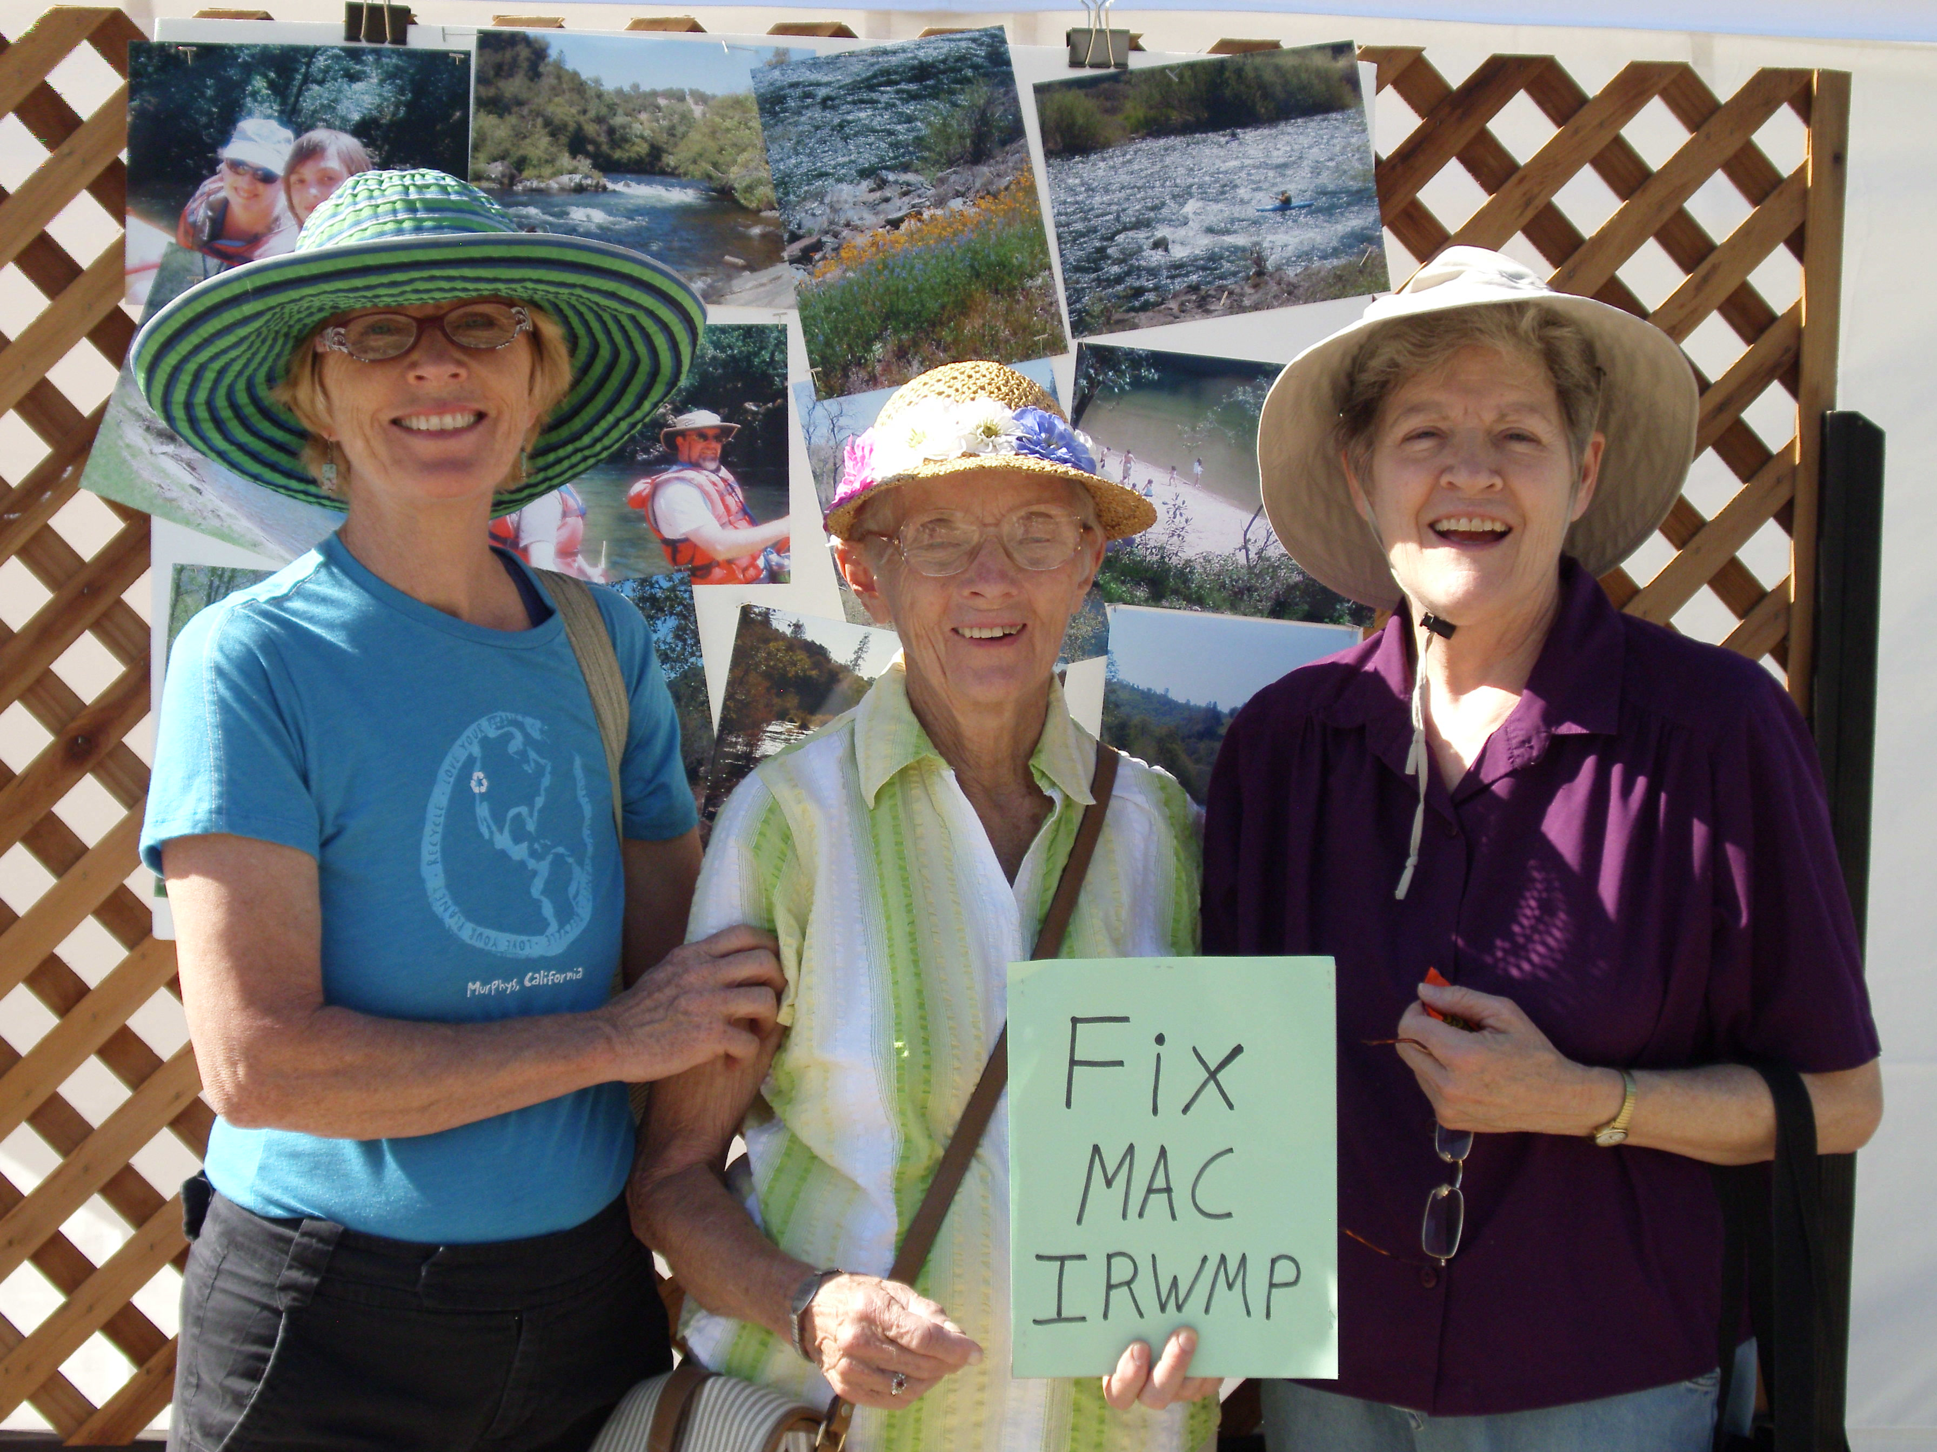

IV. Data Management
A) Obvious data gaps are not reported, and not recommended to be cured as part of projects.
1) Guideline Standards.
The IRMP must include a process for data collection, storage, and dissemination to IRWMP participants, stakeholders, the public and the State of California. This information includes project designs, feasibility studies, and information collected in every phase of project development from planning through construction, operation, and monitoring. The IRWMP should explain the data needs of the region and the techniques to collect that data. . (2010 IRWM Guidelines, p. 22, 56-57.)
The Draft DWR review of the Final MAC IRWMP indicates that the plan meets the standard for describing the date needs for the region. We disagree.

2) Refusal to address data gaps.
“On page 5-9 of the Data Management Section, the plan states that, “[T]he MAC IRWM program will continue to search for data relevant to the MAC IRWM resource management strategies on an ongoing basis. Any identified data gaps will be filled through the identification of new data sources or new or expanded monitoring activities.”
In our comments on the draft plan, we identified some of the obvious data gaps. Some additional data needs related to the projects and plan include:
-Identifying the natural hydrograph for ephemeral the streams that CCWD wants to use to distribute water.
-Getting AWA to complete a strategic capital improvement plan that assesses the cost of projects per beneficiary, and assess ratepayer ability and willingness to pay for infrastructure improvements.
-Identifying and reconciling the growth projections in Amador and Calaveras counties used by the local, regional, and state planning and public service agencies; and the expected level of growth that can be accommodated by these agencies without a decline in level of service.
However, when we requested that the plan acknowledge these data needs, the RPC refused. (Response to Comments, Number 65.) Instead identifying and filing data gaps this was deferred until the next IRWMP Update. (See Final MAC IRWMP Update, p. 4-15.)
We hope that DWR will direct UMRWA to list the data gaps in the plan, and to begin to fill these gaps with the data that are so critical to project feasibility, plan financing, and plan implementation.



V. Finance
A) The plan fails to disclosure of O&M costs and the percentage of funding from each source.
1) Statutory Provisions and Guideline Standards.
Water Code Section 10541, Subdivision (e)(8), indicates that the IRWM Guidelines must require that an IRWMP include, “A plan for implementation and financing of identified projects
and programs.”

The Guidelines for the Finance Section of an IRWMP properly require a description the funding sources for specific projects and programs. Project information should include sources of funding for project construction, operation and maintenance. The percentage of funding from each source should be identified. The intent of this section is not to demonstrate that all project funding has already been secured, but to demonstrate that the project proponent has thought through how the entire project will be financed. (2010 IRWM Guidelines, pp. 22, 58-59.)
In most cases, State funding provides only a very small supplement to the local funds necessary to implement water and wastewater treatment projects. Most of the project costs will be borne by local entities. The Finance section should explain how the many funding pieces fit together for each project.
The Draft DWR review of the Final MAC IRWMP indicates that the plan meets the finance standard. We disagree.

2) Failures to provide O&M Costs and the percentage of funding from each source.
Final MAC IRWMP Section 4.4 and Appendix D deal with financing the plan.
The table in Appendix D does not identify operation and maintenance costs for projects, and it does not disclose the funding sources by percentage of costs, as does the sample table in the IRWM Guidelines. These are huge issue related to the financial feasibility of the IRWMP. As noted in this section of the Final MAC IRWMP Update, payment of the “O & M” costs “will likely come primarily from local sources including rates, fees, and assessments.” Also, ratepayers want to know what their share of the total project costs will be. In these rural counties with very few ratepayers, the personal share of project costs can skyrocket quickly. Local economic conditions are not good, and these costs can result in real economic hardship. The lack of this cost and cost share information is especially difficult for the under 8,000 AWA connectors, who are looking at an IRWMP that proposes over $190 million in capital improvements, and who have no Capital Improvement Plan to consult for further details.
Not disclosing the “O&M” costs and not disclosing the percentage of total costs to be borne by local funding sources suggests that project proponents we have not “thought through financing of the plan and implementation of the projects.” (2010 IRWM Guidelines, p. 59.)
We hope that DWR will direct UMRWA to amend Appendix D in the Final MAC IRWMP to include estimates of the O&M costs and the local cost shares for projects.

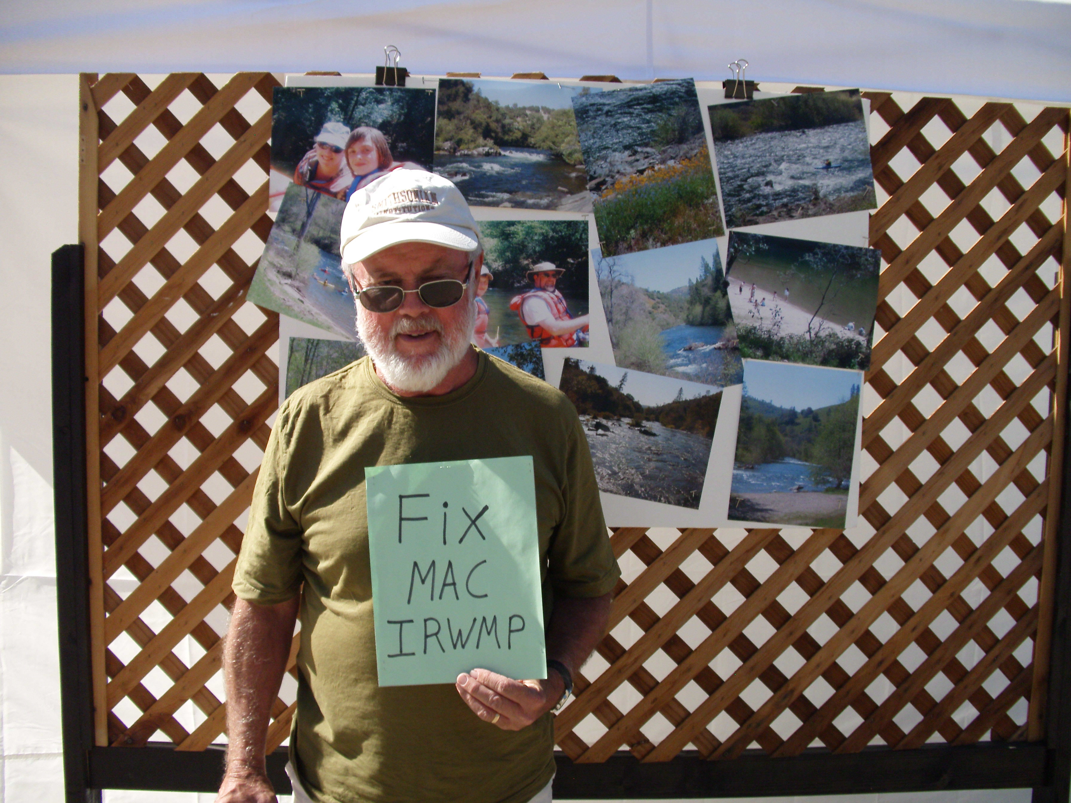

VI. Technical Analysis
A) The MAC IRWMP fails to disclose uncertainty regarding data.
1) Guideline Standards.
The IRWMP must reference the documents and the data analyses that support the plan. The intent of this standard is to ensure that the IRWMP is based upon sound information. The IRWMP must explain the techniques used to forecast water management needs throughout a plan’s 20-year horizon. The IRWMP must explain why the information used is adequate, and provide references to its sources. For each data source, an IRWMP explains what the study did, what outcomes resulted, what level of uncertainty applies to the data, and how the data was used in the IRWMP. (2010 IRWMP Guidelines, pp. 22, 59-60.)
The Draft DWR review of the Final MAC IRWMP indicates that the plan meets the standard for technical analysis. We disagree.

2) Failure to disclose data uncertainty.
Final MAC IRWMP Section 4.5 includes Table 4-2 that lists the key project support studies used in the MAC IRWMP Update. That list does not identify the level of uncertainty for any of the data in any of the reports relied upon in the MAC IRWMP Update. As noted above, this disclosure is required by the 2010 IRWM Guidelines.
We hope that DWR will direct UMRWA to review the studies that form the basis for the MAC IRWMP and the technical feasibility of the projects. Then UMRWA can assess the reliability of these technical analyses, and put that information in Table 4-2 of the MAC IRWMP Update.
B) The plan does not identify and bridge data gaps as part of plan implementation.
1) Guideline Standards

An IRWMP identifies data gaps and how they will be bridged by IRWMP implementation. (2010 IRWMP Guidelines, pp. 22, 59-60.)
The Draft DWR review of the Final MAC IRWMP indicates that the plan meets the standard for technical analysis. We disagree.

2) Failures to identify and bridge data gaps.

Final MAC IRWMP Section 4.5 provides no specific information regarding identified data gaps, and no specific information about how those data gaps will be filled by implementation of the plan. Even where there are admitted data gaps, the MAC IRWMP Update does not specifically identify the need for those studies as part of a project, or otherwise ask for funds to fill those data gaps.
As noted above, CCWD’s irrigation water study called for further analysis of irrigation water demand. That data gap creates a huge credibility gap for the MAC IRWMP. Yet no CCWD project proposes to complete the studies needed to refine that assessment.
Another major data gap is that, although the AWA has proposed over 190 million dollars in projects, AWA has no capital improvement plan that identifies, phases, prioritizes, or finances these projects, or has the approval of the AWA Board and its ratepayers. Yet no proposed AWA project includes the funding and preparation of such a strategic capital improvement plan.
Also, although CCWD proposes to “restore” ephemeral streams by using them as conduits to deliver water (Project 23), the project does not specifically call for the study of the previous natural hydrograph to guide this restoration. (CCWD, Project 23, New Hogan Reservoir Pumping Project Application, p. 4.)
Unless the data gaps are identified and filled, incomplete agency information may just languish as such, and remain a shaky and controversial basis for seeking project funding.
We urge DWR to direct UMRWA to identify data gaps in Section 4.5 of the MAC IRWMP Update. Include in the IRWMP a request for funding to fill the data gaps in the documents upon which the plan relies. Also, if the data gaps are related to specific proposed projects, add to those project proposals the completion of the additional studies, and the funding needed to complete them.
We requested this in our prior comments on the MAC IRWMP, but the RPC deferred the analyses until the next MAC IRWMP Update. (Response to Comments, Numbers 72 through 74.)

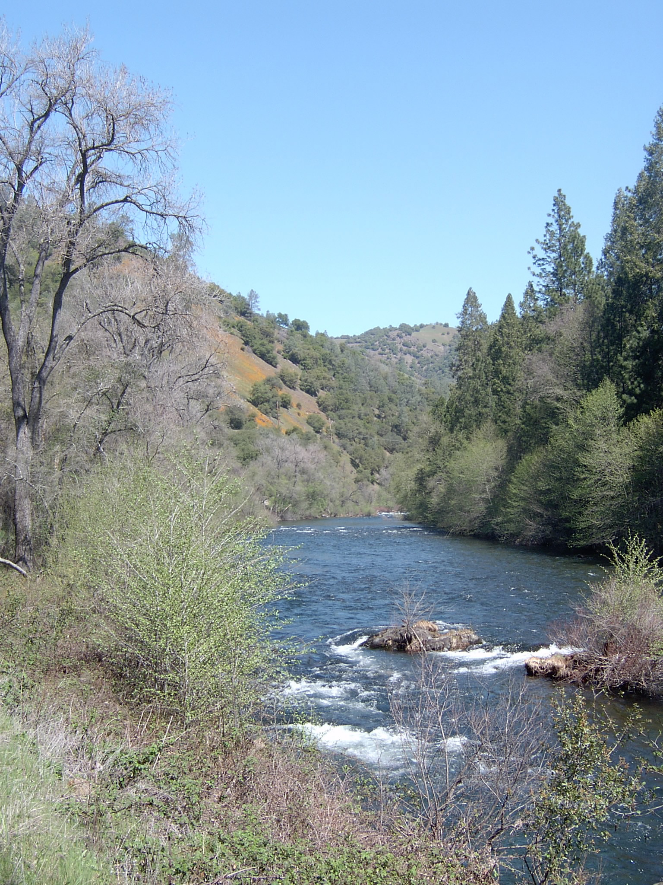

VII. Relation to Local Water Planning
A) Failure to ensure that information used from local plans was both current and accurate.
1) Statutory Provisions and Guideline Standards.
Water Code Section 10540, Subdivision (b), states that:
“(b) A regional water management group may coordinate its planning
activities to address or incorporate all or part of any of the
following actions of its members into its plan:
(1) Groundwater management planning pursuant to Part 2.75
(commencing with Section 10750) or other specific groundwater
management authority.
(2) Urban water management planning pursuant to Part 2.6
(commencing with Section 10610).
(3) The preparation of a water supply assessment required pursuant
to Part 2.10 (commencing with Section 10910).
(4) Agricultural water management planning pursuant to Part 2.8
(commencing with Section 10800).
(5) City and county general planning pursuant to Section 65350 of
the Government Code.
(6) Stormwater resource planning that is undertaken pursuant to
Part 2.3 (commencing with Section 10560).
(7) Other water resource management planning, including flood
protection, watershed management planning, and multipurpose program
planning.”

The IRWM Guidelines agree that for regional water planning to be effective, it must objectively and fairly incorporate local planning information. The intent of the standard is to ensure that an IRWMP is congruent with local plans, and includes information from current local water plans. Thus, an IRWMP will consider local plans for groundwater management, urban water management, water supply assessments, agricultural water management, flood protection, watershed management, stormwater management, low impact development, and disaster response.
In describing the use of these plans, the IRWMP includes the jurisdiction of the local plan, when it is updated, how it may be influenced by the IRWMP, inconsistencies between the local plans and the IRWMP, and how those inconsistencies might be resolved. An IRWMP must include coordination between local and IRWMP content, information from local plans that is both current and accurate, information from local plans regarding water management and climate change issues, and water management tools or criteria from local plans. (2010 IRWM Guidelines, pp. 22, 60-61.)
The Draft DWR review of the Final MAC IRWMP indicates that the plan meets the standard for relation to local water planning. We disagree.

2) Failures to use current and accurate data.
Final MAC IRWMP Update Section 4.2.2 states,
“It should be noted that not all RPC members agreed with the demands used in the MAC Plan Update (refer to Appendix G). Because the MAC Plan Update is not intended to supersede local planning documents, the best available information provided in local water plans was used.”

Two RPC members were concerned that the information to be used in the IRWMP from the local Urban Water Management Plans was not “Relevant, current and accurate” as required by the IRWM Guidelines. (2010 IRWM Guidelines, p. 61,) The two RPC members were told by the RPC facilitator, the RPC consultants, and the RPC members that the data from the UWMPs would be used, and that any questioning of that data was outside the scope of the RPC. The minutes of that meeting do not reflect that any procedure was agreed upon to allow non-agency RPC members to contribute local water planning data into the IRWMP process. The disagreement was noted and to be recorded in the MC IRWMP, Section 1.4.1. End of story. (See Minutes of RPC Meeting 10/12/11, p. 5.)
Thus, unless the NGO’s could convince the agencies to change their data voluntarily, the consultants have said that they will accept only the agency version, regardless of ample evidence to the contrary. The RPC refused to change the data used in the plan. (Response to Comments, Number 76.)
As noted above in comments on the Regional Description, the huge future growth in irrigation water demand from the CCWD UWMP is based upon a weak study using 40-year old data. Evidence of the growth or decline of irrigated agricultural lands in the Sierra Nevada Foothill Counties over the last decade provides no indication of such enormous growth in irrigated acreage, and indicates that some counties have actually lost irrigated acreage over the last decade. Furthermore, CCWD’s study did not use current water costs and crop values to estimate the financial feasibility of irrigation. Available data suggests that CCWD’s notion that every acre of land available for irrigation will be economically feasible to irrigate with 3.5 acre-feet of water per acre is without basis in fact.
Nevertheless, it is only that inflated irrigation data that is reflected in the MAC IRWMP, with no reference to the study’s disclaimer, or to the other data suggesting that the demand estimate is inflated.
Similarly, the above comments on the Regional Description explain the weaknesses in the demand estimates derived from the AWA UWMP.
We recommend that DWR direct UMRWA to amend Section 4.2.2 to provide a detailed explanation of the unresolved controversy over the quality of the water demand data.

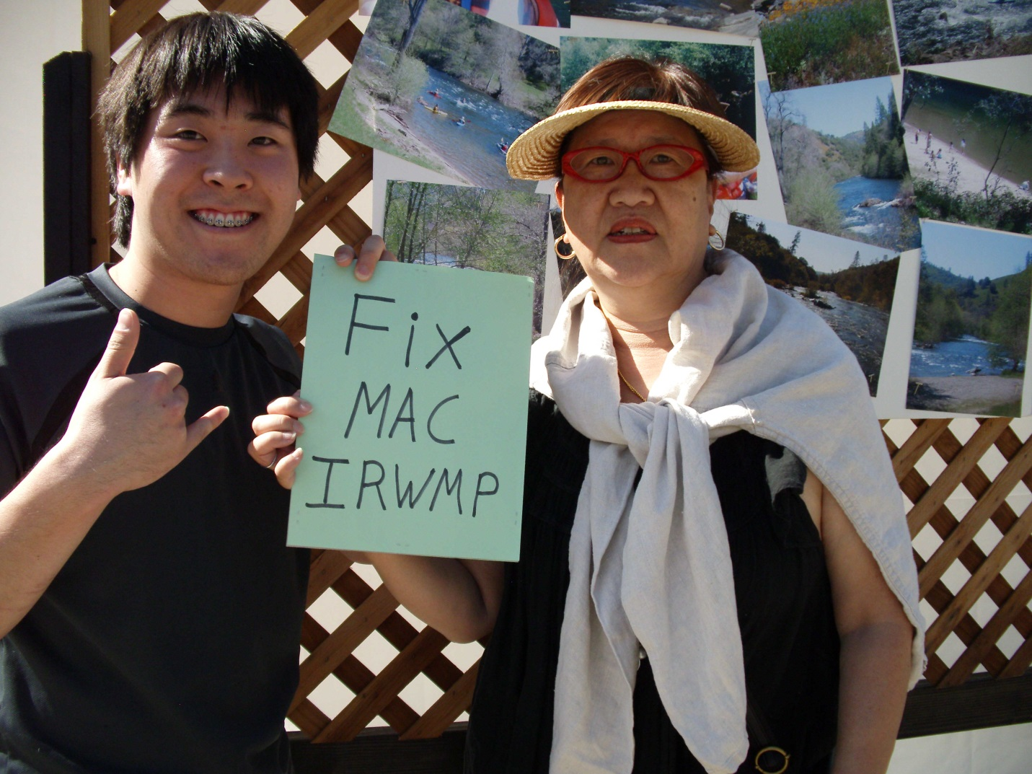

VIII. Relation to local land use planning.
A) The relationship to land use planning eroded during the MAC IRWMP Update process.
1) Guidelines
The IRWMP should include processes that foster communications between regional water managers and land use planners. (2010 IRWM Guidelines, pp. 23, 62-64.)
The IRWMP should explain the current relationship between regional water planning and local land use planning, and future efforts to improve collaboration. It should answer questions like: How do water managers and planning agencies interact? Do they provide input on each other’s projects? Are local land planners included in the IRWMP governance structure or project selection committee? Do the answers to these questions suggest that improvement is needed in future communications and collaboration? If so, the IRWMP should identify these future efforts. For example, it could suggest new forums needed for these professionals to interact.
To facilitate more effective IRWMP implementation, water agencies can seek useful input from land use agencies on issues such as flood management, groundwater recharge, conveyance facilities, stormwater management, water conservation, and watershed management. In turn, land use agencies can get useful advice from water agencies on landscaping programs, recreation, long-term planning, development review, public safety, and habitat management.
The intent of the standard is to require an exchange of knowledge and expertise among these resource professionals. The goal is for these managers to make informed, collaborative, and proactive decisions. The old model of reactive decision-making must be changed. (2010 IRWM Guidelines, pp. 23, 62-64.)
The Draft DWR review of the Final MAC IRWMP indicates that the plan meets the standard for relation to local land use planning. We disagree.

2) The failure to coordinate land use and water agencies.
Final MAC IRWMP Update Section 4.2.3 discusses coordination with water and land use agencies. That section frankly assesses the lack of land use planner participation in the MAC IRWMP Update.
During this update of the MAC IRWMP, the staff of the local planning agencies (E.g. City & County Planning Departments, public works, environmental health, LAFCO) did not attended RPC meetings or participated in the update process. Nor did representatives of the service districts and utilities (E.g. fire districts, ACTC, Calaveras COG, PG&E) regularly attended, even though those entities have a key role in future development. Thus, these agencies continue to engage in short-term and long-term planning in the comfort of their own isolated professional silos, if at all.
While State Law requires water supply studies prior to local government approval of large projects (500 units or more), such large projects are infrequent in these rural counties, and there is really very little other coordination between local water agencies and local land use agencies. As a result, water agencies continue to plan for water delivery to ridiculous levels of cumulative buildout, without consideration for the work of land use agencies, or coordination with local land use authorities. For example, AWA assumed ridiculous levels of upcountry development, based upon ludicrous planning assumptions, in its environmental assessment of the Gravity Supply Line (GSL) project. (See Exhibit 7 - Foothill Conservancy GSL Comment Letter, 12/29/09.) When ratepayers asked what priority level the GSL had in the AWA Capital Improvement Plan, they found AWA had no long-term capital improvement plan. The petal hits the metal when ratepayers are asked to pay for these seemingly randomly selected capital improvements. The AWA has lost three rate protests in recent years. (See Exhibit 3 – RPA 218 Protest Results.)
For another example, in Calaveras County the Urban Water Management Plan is preparing to deliver 100,000 acre feet of irrigation water to 29,000 acres of irrigated agriculture. No such level of growth in irrigated agriculture is mentioned in the current Calaveras County General Plan, or in the draft Agriculture Element of the proposed General Plan Update. On the positive side, both CCWD and Calaveras County are presuming average annual population growth between 1.43% and 1.97%. (Exhibit 11 – Calaveras GPU Alternatives Report, p. 8.) However, the Regional Transportation Plan indicates that the County can only fund about a third of the costs of the roads needed for that growth. (Exhibit 22 – Calaveras COG Draft RTP, pp. 110-114.) Thus, the failure to get these agencies together is resulting in isolated efforts that fail to realistically plan for the future prosperity of the region.
As noted in the section, some hope appeared on the horizon in 2009, when a stakeholder group funded by CCWD drafted a Water Element for inclusion in the Calaveras County General Plan Update. That draft element specified a very responsible degree of coordination between land use and water planners. However, the Calaveras County Board of Supervisors decided not to include the element in the General Plan Update. Then, the current CCWD General Manager declined an invitation to resurrect the joint water committee that used to include representatives of the Calaveras County Board of Supervisors and the boards of the local water purveyors. Then, budget considerations forced AWA to lay off the staff person that it had coordinating with the Planning Department in Amador County. Nevertheless, one Calaveras County land use planner is attending the monthly MokeWISE collaborative process, so only a small ember of hope remains.
Regrettably, rather than committing to future efforts to improve this situation, the plan section merely indicates what the RWMG or the RPC “can”, “may”, and “could.” (Final MAC IRWMP Update, p. 4-23.) This language does not reflect a commitment to coordinate land use and water planning.
We encourage DWR to direct the Counties, CCWD, and AWA, who signed on to the MAC IRWMP Update, to develop some organized effort to coordinate land use and water planning, and then to amend Final MAC IRWMP Update to reflect that effort.
We made a similar recommendation in previous comments on the Draft MAC IRWMP Update, but the RPC deferred the efforts until the next IRWMP Update. (Response to Comments, Number 78.) Can a Region simply pick and choose which Guideline Standards it wants to conform to during this IRWMP Update, and which Guideline Standards it wants to conform to during the next IRWMP Update? Does DWR condone this sort of compliance deferral? Can DWR provide us with a reference to the statute and or code section that justifies this?

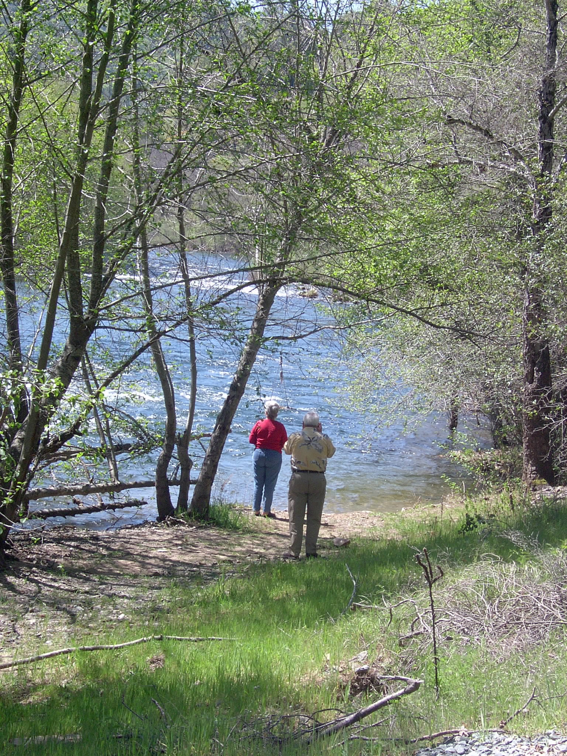

IX. Stakeholder Involvement
A) The plan update included only two inconvenient methods of stakeholder participation.
1) Statutory Standards and Guidelines
Water Code Section 10541, Subdivision (g) states that, “The guidelines shall require that the development and implementation of an integrated regional water management plan include a public process that provides outreach and an opportunity to participate in plan development and implementation to appropriate local agencies and stakeholders, as applicable to the region.”
Subdivsion (h) goes on to say:
“(h) The guidelines shall require integrated regional water
management plans to be developed through a collaborative process that
makes public both of the following:
(1) The process by which decisions are made in consultation with
the persons or entities identified in subdivision (g).
(2) The manner in which a balance of interested persons or
entities representing different sectors and interests listed in
subdivision (g) have been or will be engaged in the process described
in this subdivision, regardless of their ability to contribute
financially to the plan.”

The IRWM Guidelines do properly indicate that stakeholders are needed to gather regional information and to make regional decisions. The IRWMP processes should support stakeholder involvement. As noted above in the in the comments on the Governance section, the IRWMP explains the efforts made to identify, to inform, to invite, and to involve in the planning process water purveyors, wastewater agencies, flood control agencies, city and county governments, special district, electrical utilities, Native American tribes, self-supplied water users, environmental stewardship organizations, community organizations, tax-payer groups, recreational interests, industry organizations, state and federal agencies, and disadvantaged communities. The IRWMP must explain how the collaborative process engaged a balance of the interest groups. (2010 IRWM Guidelines, p. 23-24, 64-67.)
The intent of the standard is to ensure that all stakeholders have an opportunity to actively participate in the IRWMP decision-making process on an on-going basis.
The Draft DWR review of the Final MAC IRWMP Update indicates that the plan meets the standard for stakeholder involvement. We disagree.

2) The design of an arduous involvement process drove away too many stakeholders.
As noted above in the comments on the Governance section, the problem is that the lengthy commitment to participate on the RPC (October 2011 to January 2013) drove stakeholders away from the planning process. The only other opportunity to participate was through the public comment process. That process left much to be desired as well. It provided only a short time to review and comment on the draft IRWMP (September 14 to October 3). (With regard to local projects and plans subject to CEQA, the public is used to getting at least a 30-day review period.) As a group, the RPC resisted considering public comments received on the IRWMP projects list in May of 2012. It was only later, after RPC members and agency staff began to meet on their own to try to resolve project differences, that the RPC accepted the conflict resolution procedure. There needed to be more opportunities to participate and to provide input into the planning process between the two poles of RPC membership and public commenter.
By October 2011, the RPC has limited regular participation and limited intermittent participation. The water agencies, the Foothill Conservancy, the CPC, and the City of Plymouth attended regularly. We had occasional visits from the City of Jackson, and the Forest Service. Trout Unlimited came initially and withdrew.
Unfortunately, a lot of important parties did not attend the RPC meetings. Wastewater Agencies ARSA and San Andreas Sanitation District did not attend. The County Health Departments, responsible for regulating septic systems and small potable water systems, did not attend. The electrical utility, PG&E did not participate, even though their proposed pump-storage facility at Bear River Reservoir may conflict with EBMUD and its partners’ plans for increased water storage at Lower Bear River Reservoir. Special Districts like the Fire Districts, who depend on the upgraded pressurized water systems under consideration for funding, did not participate. BLM did not attend, even though they are a major landowner with jurisdiction over river recreation and abandoned mines and their drainage remediation. FERC did not participate, even though they have jurisdiction over power production at reservoirs in the region. Native American Tribes, a key constituent that the IRWMP is supposed to consult and serve, did not participate. Taxpayer and ratepayer groups did not participate in the RPC, but one did provide public comments on the projects. Though one realtor did sign up to participate, she did not subsequently attend, even though she was the only representative from the commercial and industrial sector.
Sadly, some of the same mistakes are being repeated in the MokeWISE collaborative process. The time commitment discourages stakeholder participation. The first public outreach effort was poorly targeted and poorly attended. The only group the outreach effort inspired to seek membership in MokeWISE Collaborative Group (MCG), a ratepayer organization, was denied membership in the MCG. Fortunately there are multiple levels of participation in the MokeWISE process, so people outside the MCG can inform and influence the process.
We encourage DWR to direct UMRWA to complete a better public outreach effort and document that in an amendment to the Final MAC IRWMP Update.

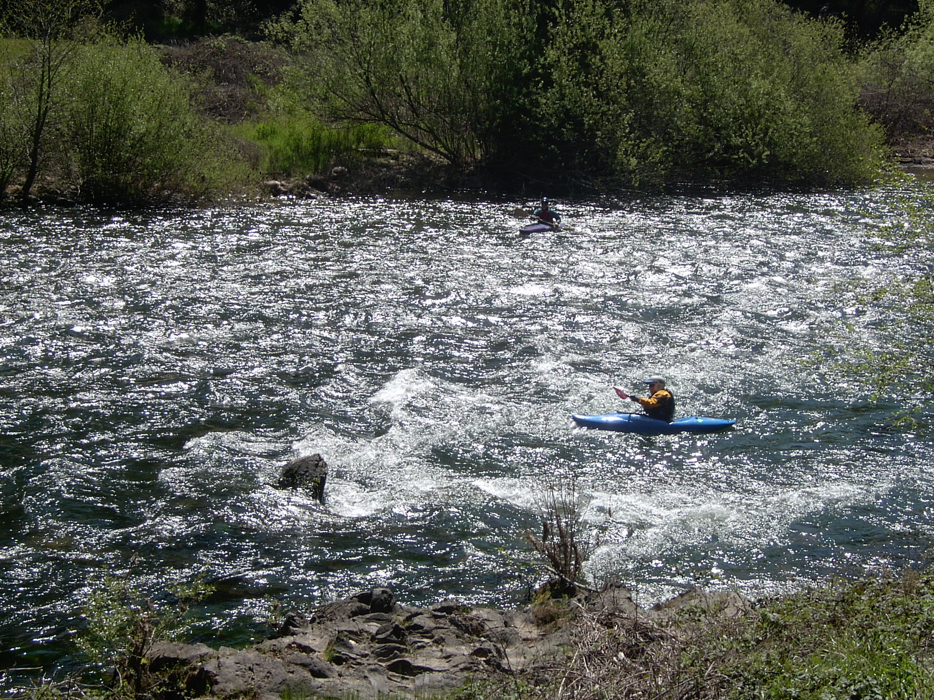

Conclusions
From a fiscal, environmental, population growth, economic development, and public works standpoint, there is a lot riding on the adequacy of an IRWMP. Now is not the time to try to figure out how little we have to do to minimally comply with the IRWM Guidelines. Now is not the time to see how many guidelines we can get away with ignoring or “finessing.” Now is not the time to present sunny half-truths. Now is the time to comply with the IRWM Guidelines. Now is the time to get UMRWA to tell the whole truth to DWR. It is that whole truth that best displays the region’s need for help.

