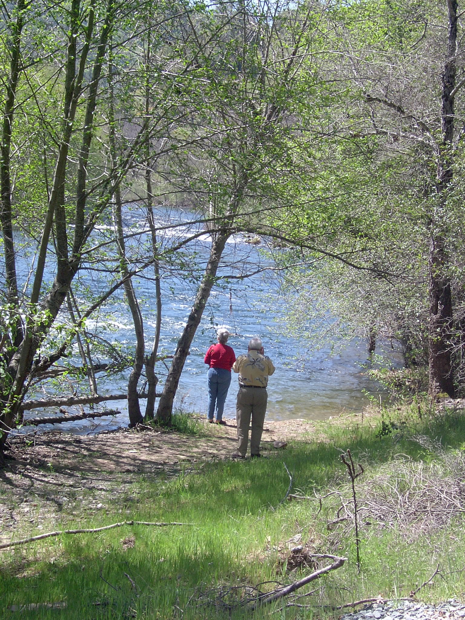

7) Impacts and Benefits
A) Standards
This section contains a screening-level review of project impacts and benefits, including those directly affecting environmental justice, disadvantaged communities, and Native American tribes. This review should be used in the future when plan performance is monitored, to see if some project benefits did not result, or if additional adverse impacts did result. Any such changes must be noted when the plan is updated. (2010 IRWM Guidelines, p. 22, 51-55.)
B) Challenge: To provide a general, balanced, comprehensive, and accurate the discussion of impacts and benefits.
Section 4.3 of the Draft IRWMP contains the impacts and benefits analysis.
In table 4-1 the term “Economic benefits” is not strictly accurate. According to traditional microeconomics, funding local infrastructure through grants paid out from state bond proceeds, the interest on which is paid by state taxpayers, does not result in an economically efficient allocation of resources. The actual benefit is to promote local prosperity. However, that comes at a cost to others elsewhere.
Table 4-1 needs to identify more potential impacts of projects.
Wherever the potential benefit is identified as “Economic Benefit”, the flip side of the project’s potential impacts must also be recognized. For example, as noted above, using this funding mechanism to finance local infrastructure in one place actually poses a real cost to those from another place who pay their taxes, but do not benefit from the program. Thus there is an interregional potential impact of economic loss.
For yet another example, those places that do get grants may create economic hardship for ratepayers who have to come up with the matching funds and operation and maintenance costs. If the ratepayers refuse the rate increase to pay for the operation and maintenance costs, the grant receiving agency may be thrown into fiscal crisis.
With regard to conjunctive use, this benefit comes with a cost to freedom of groundwater use. Those who use groundwater without regulation now will have to come under regulation for conjunctive use to work. This potential impact can be characterized as new regulation or loss of freedom.
With regard to water supply projects and storage facilities, one of the major impacts is recreational use displacement. People who liked flowing water recreation may have that recreation displaced by a reservoir.
Finally, with regard to water supply, water storage, water conveyance, and water treatment facilities, growth inducing and secondary impacts from growth may result.
Generally speaking, there is an imbalance in the treatment of the benefits and the impacts as presented in section 4.3.2. Following the description of each type of benefit, there is a bullet list of potential projects that could result in that benefit. This analysis goes on for 3.5 pages. At the end of that analysis there is a very general statement about potential impacts, without reference to the type of projects they correspond to. There is no bullet list of projects that could result in the impact. This analysis covers less than a page.
With regard to one project, MOKE WISE, Duck Creek Reservoir may still become a project component. Duck Creek reservoir was a component of the MOKE WISE predecessor, IRCUP. Duck Creek remains a priority for the MOKE WISE participants from San Joaquin County. That water storage project is controversial because it would involve a San Joaquin water agency condemning the land, and a wildlife conservation easement on the land that was donated to the California Department of Fish and Game. If public agencies begin to target devalued conservation easement lands for the location public infrastructure, then landowners will stop donating or selling conservation easements. These easements are not only the key to helping the State protect rare plant and wildlife habitat, they are also the key to developers statewide mitigating those habitat impacts to secure project approvals. Ironically, this mitigation need is no more prominent than in San Joaquin County, where programs are in place requiring the acquisition of agricultural land and wildlife habitat offsets.
Since this is a specific impact of a specific component of one project, it may not be appropriate for charting or listing in the very generalized discussions of impacts in this section. Nevertheless, given the gravity of this potential impact, and its statewide implications, it would be a good idea to include a paragraph on it somewhere in Section 4.3. It would improve the degree that we are integrating the concerns of a state agency and RPC members into our IRWMP. I think we would be remiss if we left the concern out of the IRWMP entirely.

C) Recommendations
Change the term “economic benefit” to “local prosperity” in Table 4-1.
Add the additional impacts noted above to Table 4-1.
Balance the presentation of benefit and impact information in Section 4.3.2, so that the description of potential impacts is followed by a list of the type of projects that could generate that impact.
Add a paragraph on the potential of Duck Creek Reservoir to end the use of conservation easements as we know them.

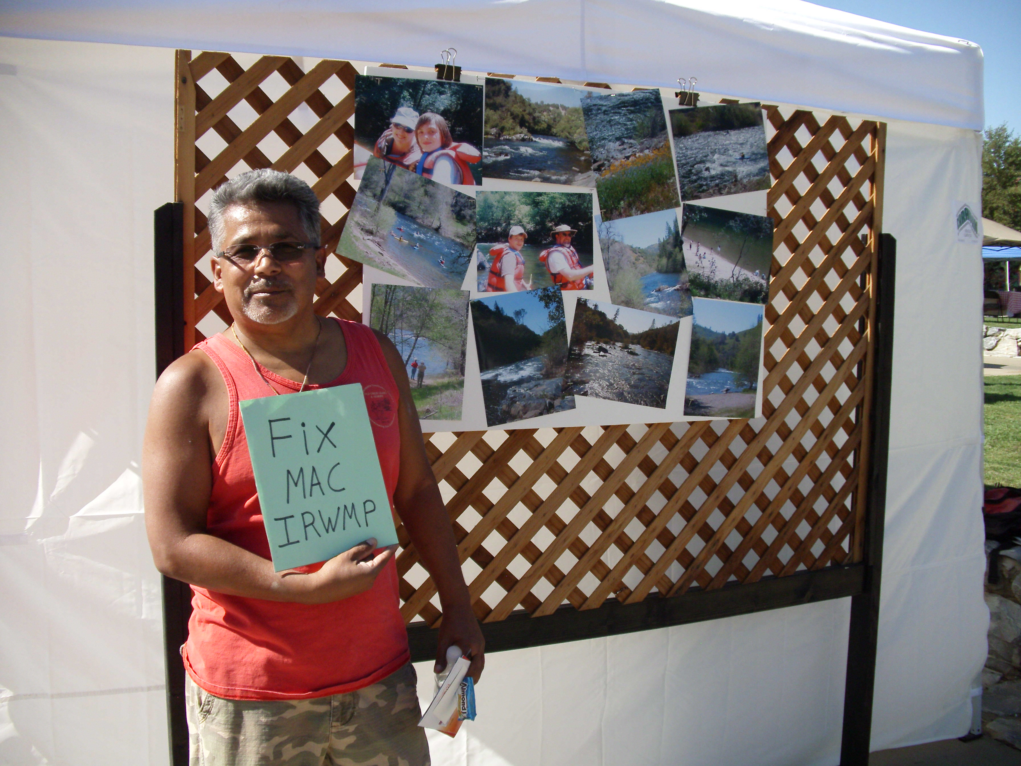

8) Plan Performance and Monitoring
A) Standards
The IRWMP must include performance measures and monitoring to be used in evaluating whether the projects are being implemented, and whether the plan is achieving its objectives. The IRWMP must explain who is responsible for evaluating plan implementation, how frequently they will do so, and who will maintain the monitoring data collected. Also, the IRWMP must identify who is responsible for project-specific monitoring, and when project-specific monitoring plans will be prepared. Such subsequent project-specific monitoring plans will include: a table of what is being monitored for each project, remedies if problems are discovered from monitoring; the monitoring location, frequency, and protocol; the methods of data collection, storage, and sharing; and procedures to fund and keep monitoring on schedule. Finally, the IRWMP must identify the adaptive management procedures for using the plan implementation monitoring data to amend and improve the IRWMP. (2010 IRWM Guidelines, p. 22, 55-56.)

B) Challenge: To fund plan performance monitoring and specify adaptive management procedures.
Section 5.1 of the Draft IRWMP covers plan performance and monitoring.
In Section 5.1.1, on page 1, the Draft IRWMP states, “A MAC Plan Performance Review will be conducted every three years (or as deemed appropriate by the RWMG when funding is available) to evaluate progress made toward achieving Plan objectives.” Thus, plan monitoring is uncertain at this time. It is subject to the availability of funding. It is telling that, in 2012, no plan monitoring results are available for the 2006 IRWMP.
Plan monitoring is a key component of the adaptive management required of IRWMP implementation. (2010 IRWM Guidelines, p. 55.) Without plan monitoring, there is no way to determine if the plan is being effective, and no way to make interim adjustments if the plan is not performing well. If UMRWA cannot make a financial commitment to MAC IRWMP plan monitoring, then perhaps it should not qualify as the Regional Water Management Group for the MAC Region.
Section 5.1.3 indicates that after project monitoring, “This information will be fed back into the project’s decision-making structure to adapt the project to better meet its overall objectives.” That statement is very vague. Which decision-making structure will be activated? Will the RPC or UMRWA, that recommended the project for funding, review the project monitoring data to see if it meets the objectives of the MAC IRWMP? Will the implementing agency review the project implementation to see if it is meeting the agency primary objectives, which may not be as broad as those of the IRWMP? Will DWR, the project’s funding partner, review the data to see if it meets DWR’s primary objectives, which also may differ from those of the agency or the IRWMP? Will any of these evaluations alert the public that this review and reconsideration of these projects is going on, and that public input is welcome? The general statement in the plan: “Monitoring will also provide a clear reporting mechanism for the public,” does not specifically guarantee public participation in the project review process. Adaptive management is a key part of the IRWMP. The plan needs more detail on its application.

C) Recommendations
Make a definitive commitment to fund plan monitoring.
Specify the adaptive management procedures in a way that identifies who will do what, when, and how.

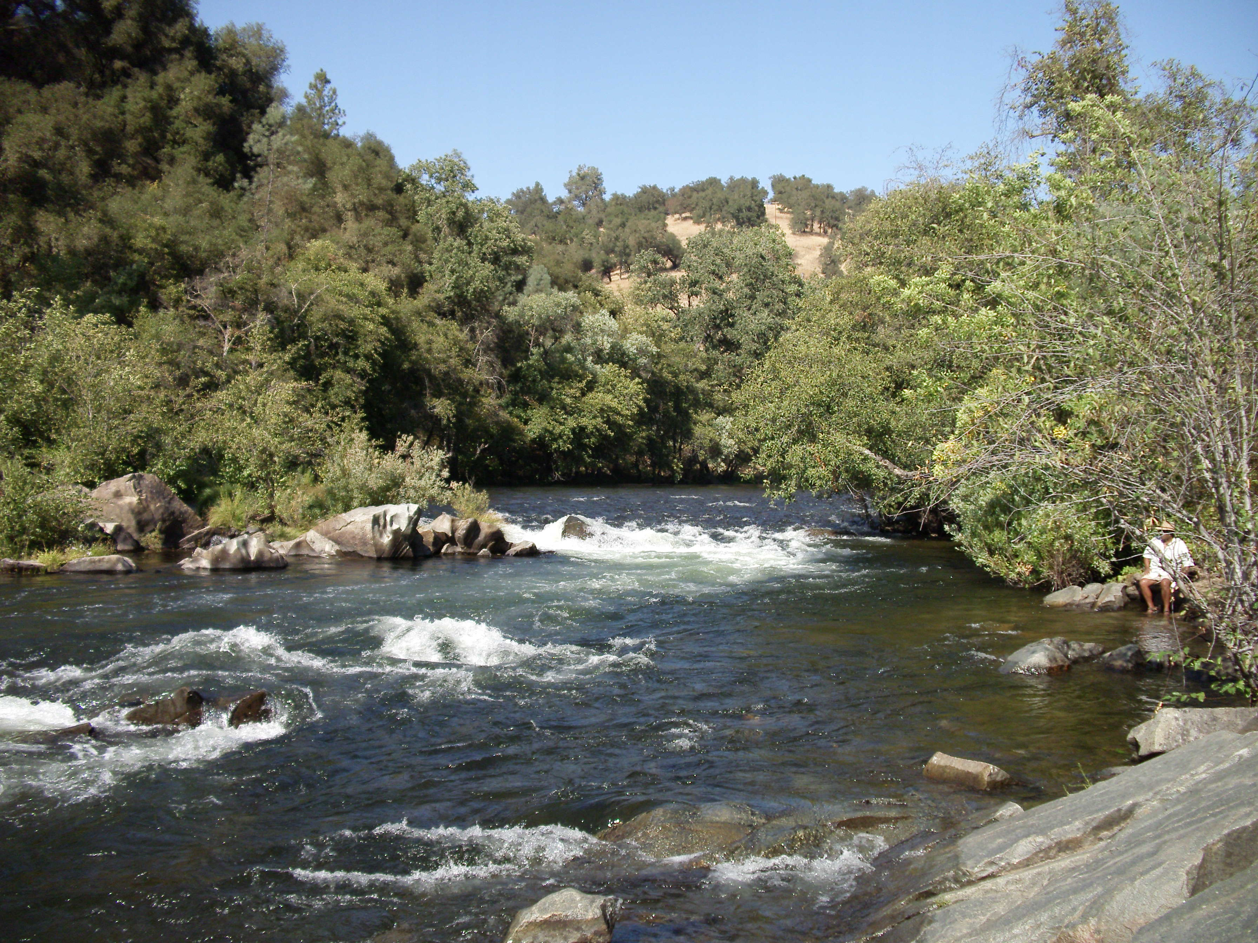

9) Data Management
A) Standards
The IRMP must include a process for data collection, storage, and dissemination to IRWMP participants, stakeholders, the public and the State of California. This information includes project designs, feasibility studies, and information collected in every phase of project development from planning through construction, operation, and monitoring.
The IRWMP should explain the data to be collected, the data collection techniques, how stakeholders contribute data, who will maintain the data, quality control measures for data, data sharing procedures with interested parties and government agencies, and efforts to generate and share data compatible with State databases. (2010 IRWM Guidelines, p. 22, 56-57.)
The public availability of this data is essential to ensure the accountability of local and state agencies. This data will help to determine if projects delivered the promised benefits, if their benefit and cost analyses in the IRWMP were accurate, and if the State chose to spend money wisely. This data management procedure will help stakeholders in an ongoing effort to provide information useful to the next IRWMP update.
B) The Challenge: To provide a platform for sharing information that is a two way street.
Draft IRWMP Section 5.2 deals with data management. It explains how project sponsors can provide information to the centralized DMS. However, there is no indication of how members of the public, or those on the RPC who are not project sponsors, can provide information to the centralized DMS. These stakeholders must also be allowed to contribute data in some fashion. Again, we are this late in the IRWMP process, and there is still no indication how information provided by stakeholders will be managed.
The Guidelines want the data management section to explain how data will be “shared between members of the RWMG and other interested parties and other interested parties.” That is a two way street. Section 5.2 talks about how monitoring data from project sponsors will get to the public. It does not explain how the public can provide information to the implementing agencies. What good is public review of monitoring data if there is no procedure for bringing concerns forward to the proper authorities? Does one go directly to the project sponsor with concerns? To the RPC? To the UMRWA Board? To the regulatory agency with jurisdiction? To DWR? Who in these agencies is responsible for receiving and responding to concerns regarding the IRWMP and its projects? What is their contact information? These questions should be answered in Section 5.2.
On pages 8 and 9 of Chapter 5, the Draft IRWMP identifies data needs for the MAC Region. These include water temperature, quality and streamflow data, watershed conditions, and the location of septic system problems. Is the systematic collection of this data part of the MAC IRWMP implementation? Is this data collection one of the MAC IRWMP projects? If not, how will it be funded? Is this data already collected periodically, and simply needs to be displayed on an accessible website?
On page 9, the plan goes on to state that, “[T]he MAC IRWM program will continue to search for data relevant to the MAC IRWM resource management strategies on an ongoing basis. Any identified data gaps will be filled through the identification of new data sources or new or expanded monitoring activities.” Is this data collection one of the MAC IRWMP projects? If not, how will it be funded? This affirmative declaration seems in conflict with other statements in the plan noting that plan monitoring is not a firm commitment, but contingent on available funding. [E.g. see, Section 5.1.1, page 1, “A MAC Plan Performance Review will be conducted every three years (or as deemed appropriate by the RWMG when funding is available) to evaluate progress made toward achieving Plan objectives.”]

Some additional data needs related to the projects and plan include:
-Identifying the natural hydrograph for ephemeral the streams that CCWD wants to use to distribute water.
-Getting AWA to complete a strategic capital improvement plan that assesses the cost of projects per beneficiary, and assess ratepayer ability and willingness to pay for infrastructure improvements.
-Identifying and reconciling the growth projections in Amador and Calaveras counties used by the local, regional, and state planning and public service agencies; and the expected level of growth that can be accommodated by these agencies without a decline in level of service.
Section 5.2.1 identifies data collection from “project sponsors” for posting in a centralized DMS on the EBMUD server. At the September 24 RPC meeting, the EBMUD representative had some questions about how that will be administered and funded.

C) Recommendations.
Identify ways that the public and stakeholders other than project sponsors can provide information to the DMS.
Provide instructions for the public and stakeholders to communicate concerns to the relevant authorities, in a manner that will result in a prompt response to the concern.
Make a clear and unambiguous commitment to plan monitoring and data collection, and identify the means for funding the efforts.
Add the data gaps noted above to the list on pages 8 and 9 of Section 5.2.1 of the Draft IRWMP. Fill those gaps.
Work out the deal with EBMUD to store the DMS on their server.

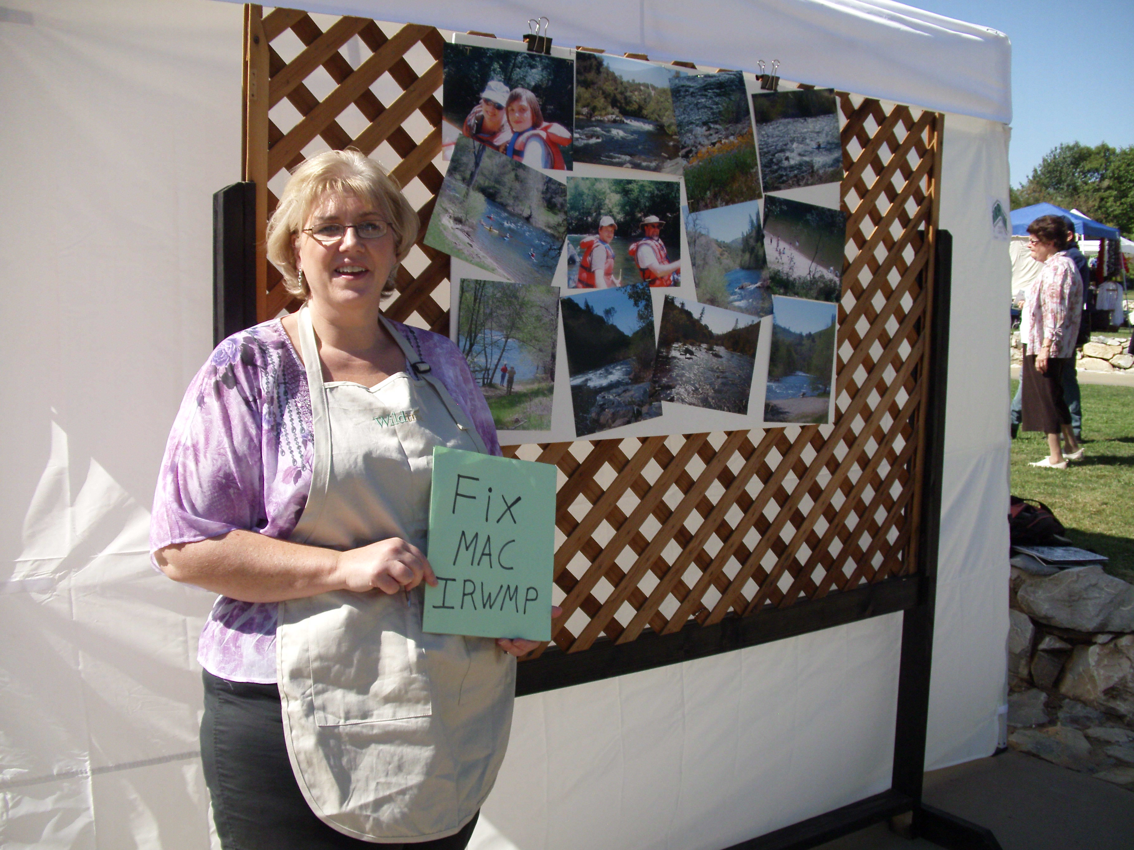

10) Finance
A) Standards
In most cases, State funding provides only a very small supplement to the local funds necessary to implement water and wastewater treatment projects. Most of the project costs will be borne by local entities. The Finance section should explain how the many funding pieces fit together for each project.
The Finance section of an IRWMP includes a description of funding for ongoing IRWMP implementation, and of funding sources for specific projects and programs. Project information should include sources of funding for project construction, operation and maintenance. The percentage of funding from each source should be identified. The IRWMP should identify the certainty and longevity of each funding source. The intent of this section is not to demonstrate that all project funding has already been secured, but to demonstrate that the project proponent has thought through how the entire project will be financed. (2010 IRWM Guidelines, pp. 22, 58-59.)
B) Challenge: Disclosing O& M costs and the percentages of funding from each source.
Section 4.4 and Appendix B deal with financing the plan. The first paragraph of Section 4.4 provides a refreshingly realistic assessment of the harsh facts regarding project funding.
The discussion of Capacity Fees on page 23 and 24 of Chapter 4 states that they are used “to achieve and maintain equity among past, present, and future customers.” However, there is no mention that this is a controversial issue for project proponent AWA. One of the chief concerns of the comments by the Ratepayer Protection Alliance is the fact that, in the recent past, connection fees have not provided for equity among present and future AWA customers. Their concern is that implementation of MAC IRWMP Update projects proposed by AWA will similarly not provide for customer equity. This concern is supported by the fact that AWA could only assure that it would meet the statewide priority of equitable benefits distribution for 4 of its 25 projects. (Appendix A, Table, Tier 1 Screening, Step 1, Reflected Goals and Statewide Priorities.) This ratepayer concern should be disclosed in this section.
The discussion of recycled water and its costs on pages 25 and 26 is too simplistic to be objective. First of all, recycled water is not a “non-water supply” project. Recycled water is an addition to an agency’s water supply. Second, when allocating the cost of recycled water, one must also consider if there is a cost saving to the wastewater disposers. In that instance, some of the costs of the recycled water should not be charged to the end user, but to the wastewater disposers. Water recycling is not a good example for the topic under discussion
The table in appendix B does not identify operation and maintenance costs for projects, and it does not disclose the funding sources by percentage of costs, as does the sample table in the IRWM Guidelines. These are huge issue related to the financial feasibility of the IRWMP. As noted in this section, payment of the “O & M” costs “will likely come primarily from local sources including rates, fees, and assessments.” Also, ratepayers want to know what their share of the total project costs will be. In these rural counties with very few ratepayers, the personal share of project costs can skyrocket quickly. Local economic conditions are not good, and these costs can result in real economic hardship. The lack of this cost and cost share information is especially difficult for the under 7,000 AWA connectors, who are looking at an IRWMP that proposes over $230 million in capital improvements, and who have no Capital Improvement Plan to consult for further details.
Not disclosing the “O&M” costs and not disclosing the percentage of total costs to be borne by local funding sources will not convince DWR that we have “thought through financing of the plan and implementation of the projects.” (2010 IRWM Guidelines, p. 59.)

C) Recommendations
Disclose expressed concerns by the Ratepayer Protection Alliance that, in practice, capacity fees charged by the AWA are resulting in an inequitable share of costs being borne by existing customers relative to future customers.
Delete the recycled water example from the discussion of “O&M” costs.
As discussed at the RPC meeting on September 24, encourage project proponents to estimate the O&M costs and the local cost shares as soon as possible, and add them to the table in Appendix B by 2014.
When considering projects for the 2014 grant package, the RPC may want to favor those noncontroversial projects that also have estimated O&M costs and local cost share percentages.



11) Technical Analysis
A) Standards.
The IRWMP must reference the documents and the data analyses that support the plan. The intent of this standard is to ensure that the IRWMP is based upon sound information. The IRWMP must explain the techniques used to forecast water management needs throughout a plan’s 20-year horizon.
The IRWMP must explain why the information used is adequate, and provide references to its sources. For each data source, an IRWMP explains what the study did, what outcomes resulted, what level of uncertainty applies to the data, and how the data was used in the IRWMP. Any data referenced should be made available to the public upon request. An IRWMP identifies data gaps and how they will be bridged by IRWMP implementation. (2010 IRWMP Guidelines, pp. 22, 59-60.)

B) Challenge: To disclose the uncertainty regarding data, and the need to fill data gaps.
According to the draft table that was supposed to go into Chapter 1, Chapter 4.5 deals with the technical analysis issues.
Section 4.5 directs the reader to the table in section 4.2.2 for the list of key planning reports used in the MAC IRWMP Update. That list includes the current AWA and CCWD Urban Water Management Plans. That list does not identify the level of uncertainty for any of the data in any of the reports relied upon in the MAC IRWMP Update. As noted above, this disclosure is required by the 2010 IRWM Guidelines. As noted in the Governance and Regional Description sections above, and the Local Water Plan section below, there is a huge level of uncertainty regarding the demand data in the Urban Water Management Plans.
In addition, Section 4.5 provides no specific information regarding identified data gaps, and no specific information about how those data gaps will be filled by implementation of the plan. Even where there are admitted data gaps, the MAC IRWMP Update does not specifically identify the need for those studies as part of a project, or otherwise ask for funds to fill those data gaps. As noted above, CCWD’s irrigation water study called for further analysis of irrigation water demand. That data gap creates a huge credibility gap for the MAC IRWMP. Yet no CCWD project proposes to complete the studies needed to refine that assessment. Another major data gap is that, although the AWA has proposed over 230 million dollars in projects, AWA has no capital improvement plan that identifies, phases, prioritizes, or finances these projects, or has the approval of the AWA Board and its ratepayers. Yet no proposed AWA project includes the funding and preparation of such a strategic capital improvement plan. Also, although CCWD proposes to “restore” ephemeral streams by using them as conduits to deliver water (Project 23), the project does not specifically call for the study of the previous natural hydrograph to guide this restoration. (CCWD, Project 23, New Hogan Reservoir Pumping Project Application, p. 4.) Unless the data gaps are identified and filled, incomplete agency information may just languish as such, and remain a shaky and controversial basis for seeking project funding.

C) Recommendation
Before 2014, review the studies that form the basis for the MAC IRWMP and the technical feasibility of the projects. Assess the reliability of their data, and put that information in the tables in Sections 4.2.2 and 4.5. Also, where those studies identify data gaps, identify those gaps in Section 4.5. Include in the IRWMP a request for funding to fill the data gaps in the documents upon which the plan relies. Also, if the data gaps are related to specific proposed projects, add to those project proposals the completion of the additional studies, and the funding needed to complete them.

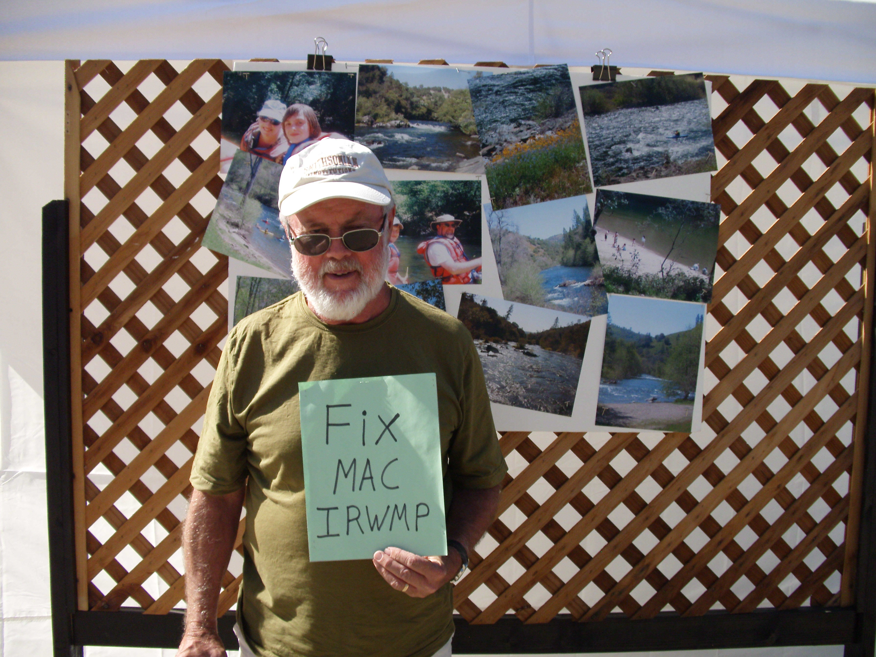

12) Relation to Local Water Planning
A) Standard
For regional water planning to be effective, it must objectively and fairly incorporate local planning information. The intent of the standard is to ensure that an IRWMP is congruent with local plans, and includes information from current local water plans. Thus, an IRWMP will consider local plans for groundwater management, urban water management, water supply assessments, agricultural water management, flood protection, watershed management, stormwater management, low impact development, and disaster response.
In describing the use of these plans, the IRWMP includes the jurisdiction of the local plan, when it is updated, how it may be influenced by the IRWMP, inconsistencies between the local plans and the IRWMP, and how those inconsistencies might be resolved. An IRWMP must include coordination between local and IRWMP content, information from local plans that is both current and accurate, information from local plans regarding water management and climate change issues, and water management tools or criteria from local plans. (2010 IRWM Guidelines, pp. 22, 60-61.)
B) Challenge: To include the whole truth in the IRWMP Update.
Section 4.2 of the IRWMP addresses this issue. This section includes a list of “initiatives and accomplishments” “indicative of local water planning” and its “interconnectivity with the IRWMP Update. The first example listed is “Inter-regional Conjunctive Use Concept Evaluation.” and its identification of the Inter-regional Conjunctive Use Project.” (DRAFT IRWMP, Chapter 4, p. 8.)
Unfortunately, because there is a lot not disclosed in that discussion of IRCUP, this is another section of the Draft MAC IRWMP Update that presents a one-sided and too rosy a picture of the actual planning process. What that discussion does not disclose is that the Integrated Regional Conjunctive Use Project (IRCUP) included two projects (Duck Creek Reservoir and Pardee Reservoir Expansion) strongly opposed by local, regional, and statewide conservation groups; and the former criticized by the State Department of Fish and Game. (Exhibit 19, DFG, Letter on Duck Creek, pp. 2-3.) In fact, the IRCUP failed to make the cut for inclusion in the Draft MAC IRWMP projects list. Furthermore, despite promises in the adopting resolution for the 2006 IRWMP, EBMUD did not involve Amador and Calaveras stakeholders in a collaborative process to plan for Pardee Reservoir Expansion. Instead, they formed a Community Liaison Committee that did not include Amador and Calaveras representatives. (Exhibit 20 – 2009 EBMUD Hearing, Testimony of Steve Wilensky, p. 4.) Not surprisingly given the extent of public opposition to these projects, both of the Duck Creek and Pardee Expansion projects have already resulted in litigation. (See Exhibit 21 – Ruling in Foothill Conservancy v. EBMUD.) Thus, while I would somberly agree to characterize the process that birthed IRCUP as unfortunately “indicative of local water planning,” I would not characterize this historical mistake as having direct or close interconnectivity with the MAC IRWMP Update. Instead, today there is some hope for conflict resolution on this front, because the next inter-regional planning process, MOKE WISE, includes more participation by local conservation groups at the feasibility study and project design phases.
Section 4.2.2 indicates states that the MAC IRWMP update was developed “based on collaborative discussions” that identified shared needs and “opportunities for collaboration.” The section then goes on to list the data sources used in the IRWMP. The highly finessed implication being that the data sources used for the plan were the result of the immediately aforementioned collaborative effort. That implication is not accurate.
Two RPC members were concerned that the information to be used in the IRWMP from the local Urban Water Management Plans was not “Relevant, current and accurate” as required by the IRWM Guidelines. (2010 IRWM Guidelines, p. 61,) The two RPC members were told by the RPC facilitator, the RPC consultants, and the RPC members that the data from the UWMPs would be used, and that any questioning of that data was outside the scope of the RPC. The minutes of that meeting do not reflect that any procedure was agreed upon to allow non-agency RPC members to contribute local water planning data into the IRWMP process. The disagreement was noted and to be recorded in the MC IRWMP, Section 1.4.1. End of story. (See Minutes of RPC Meeting 10/12/11, p. 5.)
Thus, unless the NGO’s could convince the agencies to change their data voluntarily, the consultants have said that they will accept only the agency version, regardless of ample evidence to the contrary.
As noted above in comments on the Regional Description, the huge future growth in irrigation water demand from the CCWD UWMP is based upon a weak study using 40-year old data. Evidence of the growth or decline of irrigated agricultural lands in the Sierra Nevada Foothill Counties over the last decade provides no indication of such enormous growth in irrigated acreage, and indicates that some counties have actually lost irrigated acreage over the last decade. Furthermore, CCWD’s study did not use current water costs and crop values to estimate the financial feasibility of irrigation. Available data suggests that CCWD’s notion that every acre of land available for irrigation will be economically feasible to irrigate with 3.5 acre-feet of water per acre is without basis in fact.
Nevertheless, it is only that inflated irrigation data that is reflected in the MAC IRWMP, with no reference to the study’s disclaimer, or to the other data suggesting that the demand estimate is inflated.
Similarly, the above comments on the Regional Description explain the weaknesses in the demand estimates derived from the AWA UWMP.

C) Recommendations
First, edit the discussion of IRCUP, to provide a detailed explanation of how it failed, and to explain how it was not a collaborative effort of relevant regional stakeholders. After that, feel free to acknowledge what was learned, and how we hope to avoid this mistake in the future. If we cannot demonstrate adaptive management based upon the 2006 MAC IRWMP, how can we convince DWR we will do adaptive management in the future?
Second, in the section regarding the local water planning documents used in the IRWMP, please delete the three misleading introductory sentences to Section 4.2.2 on page 9, and instead provide a detailed explanation of the unresolved controversy over the quality of the water demand data.

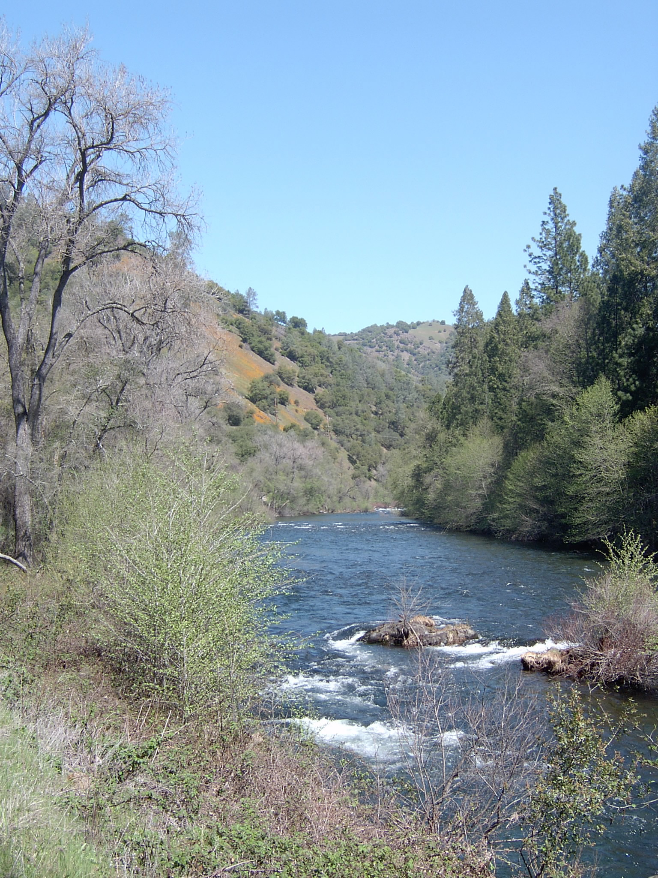

13) Relation to Land Use Planning
A) Standards
The IRWMP should include processes that foster communications between regional water managers and land use planners. (2010 IRWM Guidelines, pp. 23, 62-64.)
The IRWMP should explain the current relationship between regional water planning and local land use planning, and future efforts to improve collaboration. It should answer questions like: How do water managers and planning agencies interact? Do they provide input on each other’s projects? Are local land planners included in the IRWMP governance structure or project selection committee? Do the answers to these questions suggest that improvement is needed in future communications and collaboration? If so, the IRWMP should identify these future efforts. For example, it could suggest new forums needed for these professionals to interact.
To facilitate more effective IRWMP implementation, water agencies can seek useful input from land use agencies on issues such as flood management, groundwater recharge, conveyance facilities, stormwater management, water conservation, and watershed management. In turn, land use agencies can get useful advice from water agencies on landscaping programs, recreation, long-term planning, development review, public safety, and habitat management.
The intent of the standard is to require an exchange of knowledge and expertise among these resource professionals. The goal is for these managers to make informed, collaborative, and proactive decisions. The old model of reactive decisionmaking must be changed.

B) Challenge: To improve the working relationship between land use planning and water agencies.
The crosswalk table indicates that Chapter 4.2 discusses Standard 13, Coordination with Water and Land Use Agencies. That section only mentions that local governments were represented in the 2006 MAC IRWMP. There is no mention of planning staff participation, nor any sharing of information between land use planning and water agencies.
During this update of the MAC IRWMP, the staff of the local planning agencies (E.g. City & County Planning Departments, public works, environmental health, LAFCO) have not attended RPC meetings or participated in the update process. Nor have representatives of the service districts and utilities (E.g. fire districts, ACTC, Calaveras COG, PG&E) attended, even though those entities have a key role in future development. Thus, these agencies continue to engage in short-term and long-term planning in the comfort of their own professional silos, if at all.
While State Law requires water supply studies prior to local government approval of large projects (500 units or more), such large projects are infrequent in these rural counties, and there is really very little other coordination between local water agencies and local land use agencies. As a result, water agencies continue to plan for water delivery to ridiculous levels of cumulative buildout, without consideration for the work of land use agencies, or coordination with local land use authorities. For example, AWA assumed ridiculous levels of upcountry development, based upon ludicrous planning assumptions, in its environmental assessment of the Gravity Supply Line (GSL) project. (See Exhibit 7 - Foothill Conservancy GSL Comment Letter, 12/29/09.) When ratepayers asked what priority level the GSL had in the AWA Capital Improvement Plan, they found AWA had no long-term capital improvement plan. The petal hits the metal when ratepayers are asked to pay for these seemingly randomly selected capital improvements. The AWA has lost three rate protests in recent years. (See Exhibit 3 – RPA 218 Protest Results.)
For another example, in Calaveras County the Urban Water Management Plan is preparing to deliver 100,000 acre feet of irrigation water to 29,000 acres of irrigated agriculture. No such level of growth in irrigated agriculture is mentioned in the current Calaveras County General Plan, or in the draft Agriculture Element of the proposed General Plan Update. On the positive side, both CCWD and Calaveras County are presuming average annual population growth between 1.43% and 1.97%. (Exhibit 11 – Calaveras GPU Alternatives Report, p. 8.) However, the Regional Transportation Plan indicates that the County can only fund about a third of the costs of the roads needed for that growth. (Exhibit 22 – Calaveras COG Draft RTP, pp. 110-114.) Thus, the failure to get these agencies together is resulting in isolated efforts that fail to realistically plan for the future prosperity of the region.

C) Recommendations
First, during 2013 there needs to be meetings (or series of meetings) in Amador and in Calaveras counties so that each of the land use and public service agencies can present their long-term plans for serving existing residents and the additional population and economic growth they expect. Then they need to compare these plans for consistency. Where inconsistencies exist, the agencies and districts need to come to some agreement on some basic level of growth that they all can accommodate. Each agency can then make an interim plan to most efficiently and effectively serve the existing population and the additional basic level of growth. The projects that are needed to serve existing residents and that basic level of growth need to become a high priority for the agencies. Then, the projects in the IRWMP project’s list can reflect those high priority projects. The MAC IRWMP can be amended to describe these meetings and to summarize their results. Since both Amador and Calaveras counties are in the middle of comprehensive General Plan Update processes, now is the perfect time to begin these agency coordination efforts, and to inform those planning processes.
Second, there needs to be a quarterly public meeting of these agencies to exchange current project lists and to consult each other regarding the lists. It is shocking to me that AWA is adopting two CFDs, and not providing basic map information the LAFCO staff, simply because LAFCO approval is not required by law. If we are ever to get public support to implement government plans, the agencies will have to show more coordination and collaboration. As Air Quality planners in the Bay Area in the 1980’s, we met monthly with ABAG and Caltrans to review project lists and compare notes. Without communication and coordination, government planners with conflicting ideas just confuse the public they are supposed to serve.
Currently, Amador County schedules monthly meetings of its own staff to publicly review proposed land use projects. Lately, many of these meetings have been canceled due to lack of project applications to review. Perhaps one of these meetings per quarter could be re-directed toward the interagency sharing and discussion of projects and plans discussed above.
These efforts would meet the IRWM standard to describe “future efforts in the process of establishing a proactive relationship between land use planning and water management.” (2010 IRWMP Guidelines, p. 63.) The IRWMP Guidelines create a reason and a financial incentive for initiating and continuing these inter-agency communication efforts.
If we are not going to do the above, at least explain what is being done to coordinate water and land use planning in the MAC Region. For example, a draft water element for the Calaveras County General Plan Update includes many provisions for getting the County and the CCWD to work together better. (See Exhibit 23, Calaveras GPU Draft Water Element.) This issue of land use and water agency coordination is not treated with any detail in section 4.2 of the Draft IRWMP. If precious little is being done, then admit that. Don’t just “finesse” the issue.

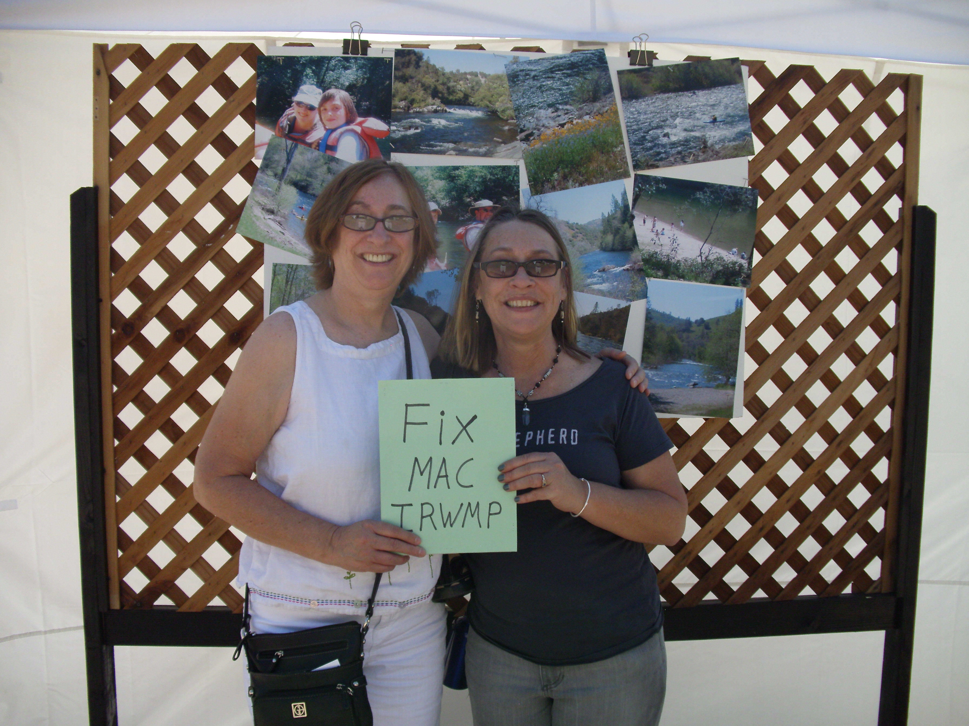

14) Stakeholder Involvement.
A) Standards
The intent of the standard is to ensure that all stakeholders have an opportunity to actively participate in the IRWMP decisionmaking process on an on-going basis.
Stakeholders are needed to gather regional information and to make regional decisions. The IRWMP processes should support stakeholder involvement. As noted above in the in the comments on the Governance section, the IRWMP explains the efforts made to identify, to inform, to invite, and to involve in the planning process water purveyors, wastewater agencies, flood control agencies, city and county governments, special district, electrical utilities, Native American tribes, self-supplied water users, environmental stewardship organizations, community organizations, tax-payer groups, recreational interests, industry organizations, state and federal agencies, and disadvantaged communities. The IRWMP must explain how the collaborative process engaged a balance of the interest groups. (2010 IRWM Guidelines, p. 23-24, 64-67.)

B) Challenge: To Improve Public Outreach.
As noted above in the comments on the Governance section, the problem is that the lengthy commitment to participate on the RPC (August 2011 to January 2013) drove stakeholders away from the planning process. The only other opportunity to participate is through the public comment process. That process left much to be desired as well. It provided only a short time to review and comment on the draft IRWMP (September 14 to October 3). (With regard to local projects and plans subject to CEQA, the public is used to getting at least a 30-day review period.) As a group, the RPC resisted considering public comments received on the IRWMP projects list in May. It was only later, after RPC members and agency staff began to meet on their own to resolve project differences, that the RPC accepted the conflict resolution procedure. There need to be more opportunities to participate and to provide input into the planning process between the two poles of RPC membership and public commenter.
Currently, our RPC has limited regular participation and limited intermittent participation. The water agencies, the Foothill Conservancy, the CPC, and the City of Plymouth attend regularly. We have had occasional visits from the City of Jackson, and the Forest Service. Trout Unlimited came initially and withdrew.
Unfortunately, a lot of important parties did not attend the RPC meetings. Wastewater Agencies ARSA and San Andreas Sanitation District did not attend. The County Health Departments, responsible for regulating septic systems and small potable water systems, did not attend. The electrical utility, PG&E did not participate, even though their proposed pump-storage facility at Bear River Reservoir may conflict with EBMUD and its partners’ plans for increased water storage at Lower Bear River Reservoir. Special Districts like the Fire Districts, who depend on the upgraded pressurized water systems under consideration for funding, did not participate. BLM did not attend, even though they are a major landowner with jurisdiction over river recreation and abandoned mines and their drainage remediation. FERC did not participate, even though they have jurisdiction over power production at reservoirs in the region. Native American Tribes, a key constituent that the IRWMP is supposed to consult and serve, did not participate. Taxpayer and ratepayer groups did not participate in the RPC, but one did provide public comments on the projects. Though one realtor did sign up to participate, she did not subsequently attend, even though she was the only representative from the commercial and industrial sector.
Unless the RPC creates more opportunities to get input from these very important parties, the MAC IRWMP Update’s list of participants will appear too narrow, and may harm our chances of having a plan that qualifies our grants for funding in 2014.

C) Recommendations.
First, try to hold a series of individual meetings to invite key missing stakeholder groups to put their two cents worth in on the plan (i.e. city and county governments planning and health department staff, school districts, Calaveras COG & ACTC, electrical utilities, Native American tribes, self-supplied water users, community organizations, tax-payer and ratepayer groups, recreational interests, industry organizations, state and federal agencies, and disadvantaged communities.). For example, on one day you could have a meeting with City and County planning staff, COG staff, ACTC staff, School Districts.
If this does not work, delegate to RPC volunteers the responsibility of meetings one-on-one with additional stakeholder groups or their representatives. Provide RPC volunteers with questions to ask and materials to share.
Note the suggestions of these new stakeholders. If project ideas result from these meetings, encourage participants to sponsor or cosponsor a project proposal for addition to the plan. Prior to the 2014 grant package submittal, add notes on their suggestions in the implementation section, and amend the plan as needed based upon their suggestions. It is not too late for the MAC IRWMP Update to do a more comprehensive job of outreach to important participants. If we fail to do so, we will only have ourselves to blame should DWR find this flaw fatal to our MAC IRWMP.
When the next comprehensive IRWMP Update takes place, work these stakeholder subcommittees into the regular planning schedule.

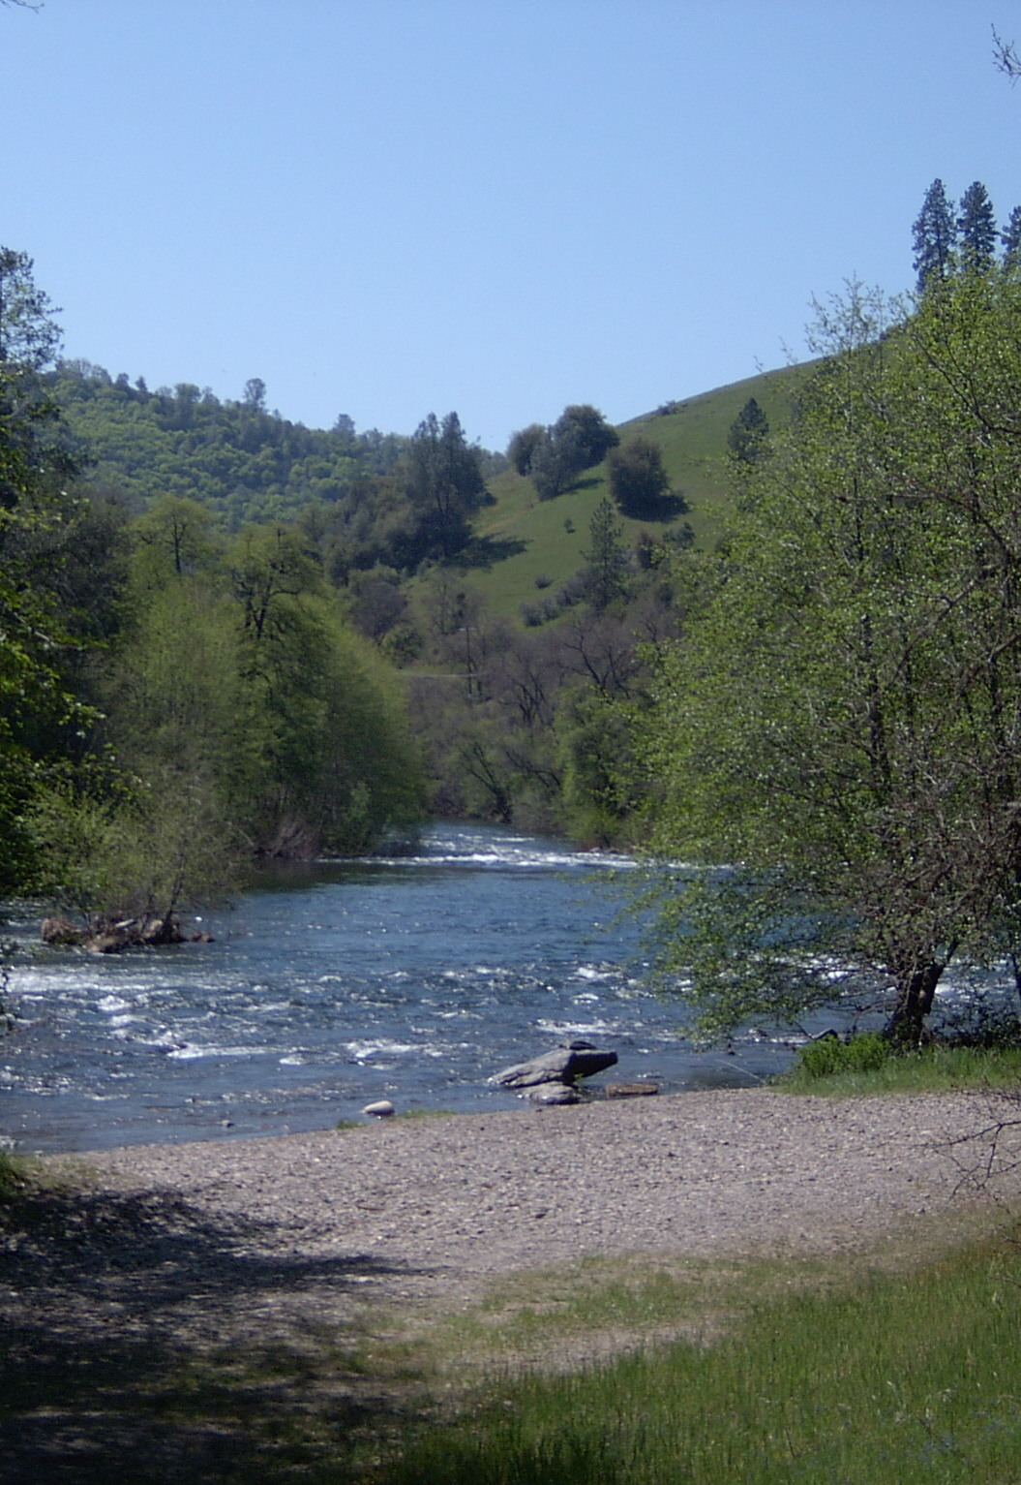

15) Coordination
There are three levels of required coordination.
First, the IRWMP must establish a process to coordinate stakeholder activities to avoid conflicts. This could include bringing local water agencies and stakeholders together in a setting where projects and activities can be discussed.
Second, the IRWMP must identify ways to collaborate with neighboring regions to avoid conflict, to avoid redundant projects, or to reveal opportunities for cooperative projects. It must identify common water management issues among neighboring regions, describe existing coordination efforts, and discuss joint project opportunities.
Third, the IRWMP must identify ways that the State and Federal governments can work with local agencies to promote effective plan and project implementation.
The intent of the standard is to reduce conflict among stakeholders and among neighboring regions; and to build effective working relationships with State and Federal agencies. (2010 IRWMP Guidelines, pp. 24, 67-68.)

B) Challenge: How to move from conflict and neglect toward collaboration.
Regarding the first standard of working out conflict among stakeholders, the region gets an A- for working out conflict over projects. Policy 4 of the plan is to “Focus on Areas of Common Ground and Avoid Prolonged Conflict.” Before the ink was even dry on the draft plan, EBMUD, AWA, and CCWD met with concerned stakeholders to go over their comments and concerns regarding the project list. These meetings are ongoing and resulting in agreement regarding some projects. We expect the meetings to continue after plan adoption, to try to resolve core policy issues. The only problem at this time is that AWA expressed concern that it may not be able to amend its projects as agreed upon in time for MAC IRWMP Update adoption in January 2013.
Regarding the second standard, for working out conflicts with other regions, Chapter 1.1.2 explains that. That section explains that the MAC region and the Eastern San Joaquin region have been engaged at regular coordination at the agency level. (Draft MAC IRWMP, Chapter 1, p. 1-5.) Unfortunately, what that section does not disclose is that the product of that coordination, the Integrated Regional Conjunctive Use Project (IRCUP), included two projects (Duck Creek Reservoir and Pardee Expansion) strongly opposed by local, regional, and statewide conservation groups. Both those projects have already resulted in litigation. Thus, I would hardly characterize the initial agreements of these agencies as a successful effort at inter-regional cooperation. Today, there is some hope for conflict resolution on this front, because the next inter-regional planning process, MOKE WISE, includes more conservation group participation.
The standard for coordination with State and Federal agencies is addressed in only two short paragraphs totaling 5 sentences. (Draft IRWMP, Chapter 2, p. 11.) The first paragraph indicates that UMRWA will coordinate with the unspecified “appropriate agencies.” The second paragraph indicates that IRWMP projects will get the necessary permits and complete the necessary environmental reviews. That is the minimum level of coordination required by law. Given that the MAC Region includes extensive BLM and USFS land and water holdings, numerous hydropower facilities regulated by FERC, an existing conflict over the use of Forest Service lands for reservoir expansion at Bear River Reservoir, and at least two existing stakeholder groups that are already coordinating with federal agencies, one would expect more details in the MAC IRWMP.
C) Recommendations
First, we strongly recommend that either AWA staff or IRWMP consultants find the time in the next three months to make the agreed upon amendments to the draft plan.
Second, in the final IRWMP, please disclose the whole truth about the results of the MAC and Eastern San Joaquin interregional coordination efforts, including the fact that it did not result in a set of projects that resolved regional conflicts.
Third, there is currently an ERC that includes stakeholders overseeing implementation of FERC Project 137 on the Mokelumne River. There is also an Amador Calaveras Consensus Group working with BLM and the USFS on forest restoration and fuel reduction projects. If the MAC IRWMP needs to improve coordination with federal agencies actively involved with watershed management, the IRWMP should commit to sending a delegate to attend one or more of these existing stakeholder groups, to provide information regarding IRWMP projects, and to report back to UMRWA.

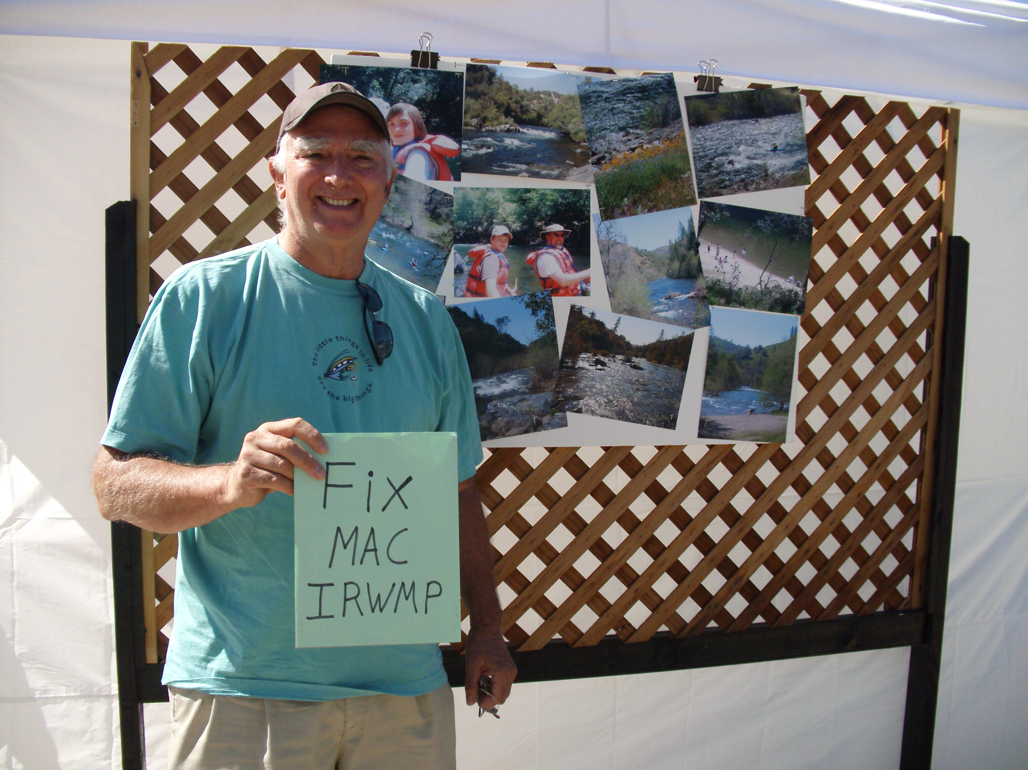
16) Climate Change
A) Standards
An IRWMP must discuss both mitigation of greenhouse gas emissions, and adaptation to the effects of climate change.
As part of this effort, an IRWMP explains how GHG emissions are disclosed and considered when choosing among project alternatives. In many cases, this is currently done late in the planning process through quantitative project-level analyses in accordance with the California Environmental Quality Act (CEQA). However, the Project Review section of the IRWMP must include a less detailed analysis of a project’s contribution to reducing GHG emissions and adapting to climate change.
The IRWMP also discloses the potential impacts of climate change on the region, including the water-related impacts on public safety and ecosystems, as well as on water supply reliability. The IRWMP should address the changes in water runoff and in groundwater recharge. The IRWMP Region Description section describes these impacts.
At this time, when considering adaptations to climate change, regions are encouraged to adopt “no regret” adaptations. These are policies, projects and programs that both make sense in light of current water concerns, and also help in terms of climate change adaptation. These include ongoing practices such as increasing water use efficiency, sustaining ecosystems, and integrating flood management. The Plan Objectives and Resource Management Strategies sections of the IRWMP should include the region’s approach to these “no regret” adaptations.
The IRWMP should contain provisions explaining how adaptive management will be used to respond to climate change challenges as new information becomes available. These provisions should appear in the Plan Performance and Monitoring section of the IRWMP.
In the future, as the analytical tools become available, IRWMPs will have to provide a more detailed evaluation of the adaptability of the region’s water management systems to climate change. (2010 IRWM Guidelines, pp. 24, 68 – 76.)
B) Challenge: How to address climate change prevention and adaptation in a region that is not concerned about climate change?
Climate change is one of the areas that is supposed to be a major focus of improvement for the MAC IRWMP Update, since the 2006 plan did not meet the current climate change standards. Also, climate change is a very high State priority. The crosswalk table indicates that climate change is addressed in Section 1.3 of the MAC IRWMP Update. That section covers less than two pages. As noted below, climate change is also addressed in other sections of the Draft MAC IRWMP Update (e.g. Section 3.1, Section 3.2, and Section 4.1)
The discussion of climate change in Section 1.3 does a good job of identifying some of the primary physical changes to the environment. However, it does not trace those primary physical changes, down the chain of cause and effect, to the ultimate impacts on the human environment, and then to the means to reduce those impacts.
For example, Section 1.3 describes reduced natural water storage, but does not explain that the result could be insufficient water supplies for people and wildlife. It does not go on to note the options to adapt to this condition in the MAC Region: increased water recycling, increased water use efficiency, restoration of natural water storage systems, and increased water storage.
For another example, Section 1.3 describes a potential increase in water temperature, but it does not indicate what impacts that will have on the fish and amphibians of the MAC Region, and it does not identify the options for reducing those impacts.
For a final example, although Section 1.3 does indicate that air temperature may increase, it does not identify the potential impacts on watershed vegetation, fire safety, or surface water evaporation; and the means of reducing those impacts.
In part as a result of these deficiencies in Section 1.3, the Draft MAC IRWMP Update barely begins to identify the projects needed to adapt to the most serious water-related consequences of climate change.
The discussion of climate change does not address how GHG emission reduction was considered in evaluating projects proposed in the IRWMP. The IRWMP should note that most of the proposed project applications did not even bother to fill out the section on climate change. (See for example, applications 1 through 20, 23, 24, 25, and 27.)
Section 3.1 of the Draft MAC IRWMP Update discusses goals, objectives, and policies, but it does not specifically call out the many that address climate change adaptation. As a result, these may not get picked up by somebody reviewing the plan at DWR. For example, the Draft MAC IRWMP includes policies for the long-term balance of supply and demand, and for resource stewardship. It includes goals to insure sufficient water supply, to promote water conservation, to develop drought mitigation, and to improve natural watershed processes. It includes objectives to incorporate climate change into long-term planning, and to increase water recycling. All of these provisions of the Draft MAC IRWMP Update address climate change adaptation, and should be recognized as such in the text of Section 3.1. Let’s not burry the things we do right. Let’s highlight them.
Section 3.2. of the Draft MAC IRWMP Update discusses regional management strategies, but it does not specifically call out the many that address climate change adaptation. The strategies selected for the MAC IRWMP Update deal with water use efficiency, conjunctive use, recycled water, ecosystem restoration, forest management, and watershed management. Each of these strategies is an adaptation to climate change, and should be recognized as such in the text of Section 3.2. Let’s not burry the things we do right. Let’s highlight them.
Section 4.1 on the project review process does explain how projects were evaluated for climate change mitigation and adaptation. (See Draft MAC IRWMP Update, Chapter 4, p. 4.)
The statewide priority standards for climate change are very generous. (2012 IRWM Guidelines, p. 13.) Any project that increases water use efficiency can claim climate change benefits. This is true even if the saved water is not held in reserve for responses to drought from climate change, but is instead used to supply more developments, that in turn put more people at risk of drought. That is not really adapting to climate change. That is water agency business as usual. On the other hand, water recycling that shifts more of the local water supply to a source that is available even during a drought, and requires less raw water to serve the same population, is real adaptation to climate change. I think DWR needs to clarify what types of projects can claim climate change benefits. In the meantime, as a result of the generous statewide priority standards, 11 of the 38 projects in the Draft MAC IRWMP Update qualify as climate change response actions. (See Chapter 4, Table 1- Screening, Step 1 – Reflect Goals and Statewide Standards.)
However, the Draft MAC IRWMP Update does not look so good when one reviews the rankings of projects regarding climate change adaptation and mitigation. In the table in Appendix A, one finds that no projects get a high rating for dealing with climate change, only 4 projects get a medium rating, and all the rest of the projects get a low rating. (Chapter 4, Appendix A, Table, Tier 2 - Evaluation, Step 1 – Apply Evaluation Criteria.) In many cases, the low rating was given because the water agency proposing the project did not bother to evaluate the project’s climate change implications, and simply left that section of the project application blank. (See project applications 1 through 20, 23, 24, 25, and 27.)
This is not really a surprise. In general, the region is politically conservative, and so climate change prevention and adaptation are not high on the list of local government priorities. Even when a plan or project rises to the level of preparing an Environmental Impact Report, the issues of climate change are quickly dismissed, without the adoption of additional feasible mitigation or the serious consideration of alternatives.
As noted above in comments on plan performance and monitoring, Section 5.1 is very general in nature and lacks many important details. Unfortunately, it does not specifically discuss how monitoring and adaptive management will be used to respond to climate change challenges as new information becomes available.
C) Recommendations.
In the crosswalk table, add Section 3.1, Section 3.2, and Section 4.1 to the list of sections that address climate change mitigation and adaptation.
In Section 1.3, trace those primary physical changes noted (i.e. air temperature, water temperature, and water storage) down the chain of cause and effect to the ultimate impacts on the human environment, and to the means to reduce those impacts.
Add to the project evaluation process a primary-level assessment of GHG reductions from each project. Explain that process in Section 1.3. Report the results in of the analysis in Chapter 4.
In the text of Section 3.1 of the final MAC IRWMP Update, specifically note the many goals, objectives, and policies that address climate change adaptation.
In the text of Section 3.2 of the final MAC IRWMP Update, specify the selected regional management strategies that address climate change adaptation
At the last RPC meeting, staff encouraged the water agencies to review their projects to see if any of them deserved a higher rating for climate change mitigation and adaptation. It is my recommendation that the RPC continue to look for additional climate change response projects, even after plan adoption in January 2013, and add them to the project list before 2014.
Add to Section 5.1 a specific explanation of how monitoring and adaptive management will be used to respond to climate change challenges as new information becomes available.

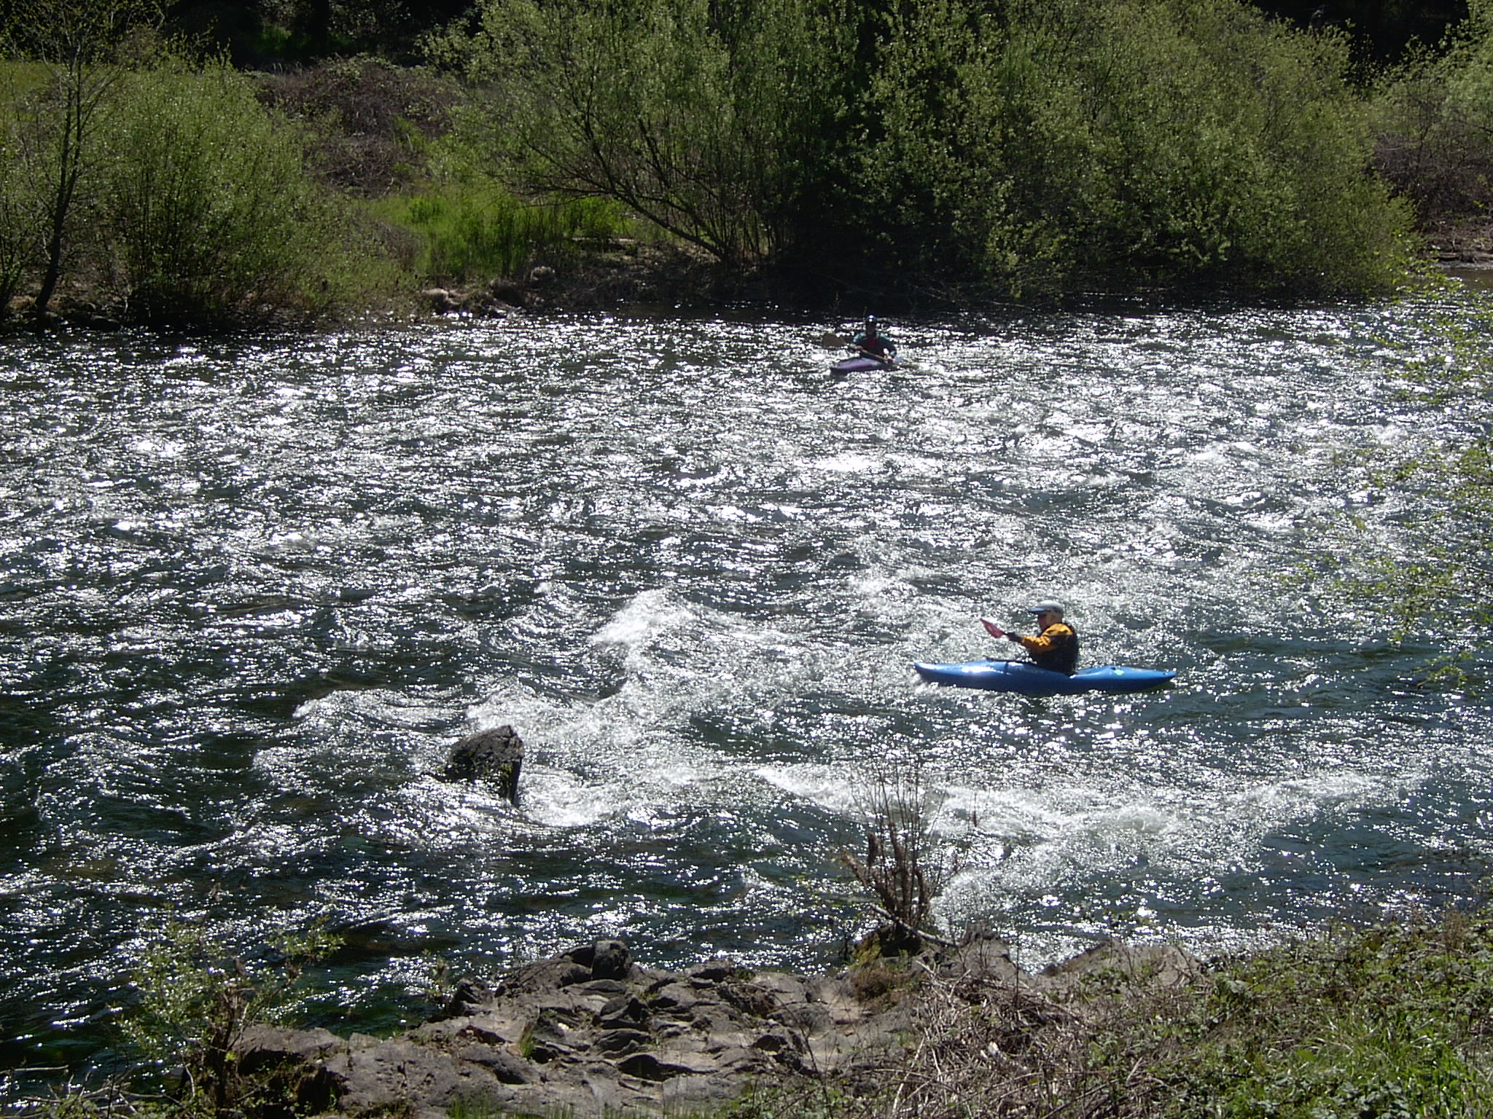

Conclusions
From a fiscal, environmental, population growth, economic development, and public works standpoint, there is a lot riding on the adequacy of an IRWMP. Now is not the time to try to figure out how little we have to do to minimally comply with the IRWM Guidelines. Now is not the time to see how many guidelines we can get away with ignoring or “finessing.” Now is not the time to present sunny half-truths to the Department of Water Resources. Now is the time to comply with the IRWM Guidelines. Now is the time to tell the whole truth to DWR. It is that whole truth that best displays the region’s need for help.

